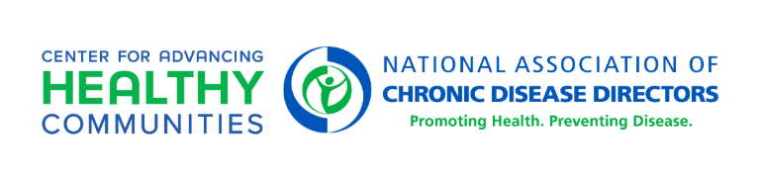

The Reaching Families with Important Nutrition Messages in Multiple Locations Campaign Application

About the Project & Campaign
In partnership with the Centers for Disease Control and Prevention (CDC), Rocket Camp, and Propellant Media, the National Association of Chronic Disease Directors (NACDD) is implementing The Reaching Families with Important Nutrition Messages in Multiple Locations Campaign project (Campaign). The Campaign will support recipients funded through the Division of Nutrition, Physical Activity, and Obesity (DNPAO)’s State Physical Activity and Nutrition (SPAN) or High Obesity Program (HOP) in amplifying health promotion messaging for mothers and caregivers of children 6 months to 5 years old that experience food and nutrition insecurity. Rocket Camp and Propellant Media, two communication agencies, will provide expertise and support to up to five states in the tailored dissemination and promotion of existing, pre-approved digital and social media advertisements from DNPAO’s State and Community Health Media Center that focus on nutrition practices, specifically sugary drinks, for children 6 months to 5 years old.

Note: Rocket Camp will cover all direct expenses associated with identifying and implementing a media plan for paid placement and promotion of digital ad campaign(s) in each selected state. The amount of funds allocated for each state/location will vary based on the density of the population of focus.

Expectations of Selected States/Locations
Selected states/locations will:
- Work with Rocket Camp and Propellant Media to develop and implement a plan for paid placement and promotion of the digital ad campaign(s).
- Convene partners in meetings with Rocket Camp and Propellant Media to discuss placement and promotion opportunities for the digital ad campaign(s).
- Leverage other state-/location-specific communication channels to disseminate the digital ad campaign(s) (e.g., State Health Department website, social media channels, email list, etc.).
- Based on evaluation metrics collected by Rocket Camp and Propellant Media, pivot in placement and promotion activities, as needed.
- Support sharing of lessons learned, as needed, with other states/locations.

Eligibility Criteria
States must:
- Be a current SPAN or HOP recipient
- Be able to meet the expectations described above
- Have existing partnerships in place that can support the goals of the campaign and achieving maximum reach

Application Completion Instructions
- Complete the Application Form online via this link. A copy of the application can be found in Appendix A to support completion with your team.
- Applications must be submitted online by 11:59 PM ET Friday, January 30, 2026. States will be notified of their selection by Friday, February 6, 2026.

Selection Process
The selection process is competitive. Up to five states will be selected based on the quality of their applications and demonstrated ability and capacity to participate in the project.

If you have questions about the application, please contact Heidi Milby, Associate Director, Center for Advancing Healthy Communities, NACDD at hmilby@chronicdisease.org.

The Reaching Families with Important Nutrition Messages in Multiple Locations Campaign project is supported by the Centers for Disease Control and Prevention (CDC) of the U.S. Department of Health and Human Services (HHS) as part of a financial assistance award totaling $600,000 with 100 percent funded by CDC/HHS. The contents are those of the author(s) and do not necessarily represent the official views of, nor an endorsement by, CDC/HHS or the U.S. Government.
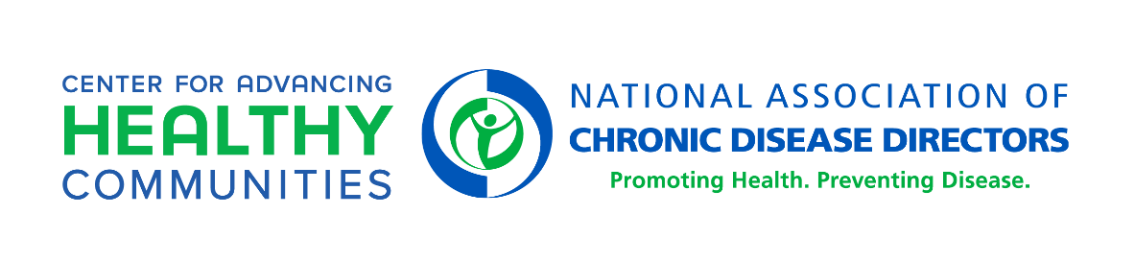

The Reaching Families with Important Nutrition Messages in Multiple Locations Campaign Project

Appendix A: Application Form

Please note the word limit for questions with an asterisk (*).

Applicant Contact Information
State | Type response
Are you a SPAN or HOP recipient? | Type response
Agency/Organization Name | Type response
Agency/Organization Address | Type response
Primary Contact Name | Type response
Primary Contact Title | Type response
Primary Contact Email Address | Type response
Primary Contact Phone Number | Type response
Communications Lead Name, if applicable | Type response, if applicable
Communications Lead Title, if applicable | Type response, if applicable
Communications Lead Email Address, if applicable | Type response, if applicable
Communications Lead Phone Number, if applicable | Type response, if applicable

- In partnership with CDC, Rocket Camp, and Propellant Media, NACDD has been implementing this project since 2022 (SPINE Infant and Toddler Nutrition Campaign project or Multi-Location Young Child Nutrition Campaign project). Has your state or organization previously participated in this project?

☐ Yes
☐ No

- Describe how your participation in the project will support your existing efforts around food and nutrition security. If you participated in the SPINE Infant and Toddler Nutrition Campaign or Multi-Location Young Child Nutrition Campaign, also specify how participation in the project will enhance previous efforts. (200 words or less)*
Type response

- The anticipated launch of campaign efforts across selected states/locations is March or April 2026. To meet this deadline, does your state have the ability to swiftly implement project activities upon notice of selection (e.g., grant social media ad account access, add content to landing page or potentially create a landing page, add marketing tags to pages)?

☐ Yes
☐ No

- The campaign messages will target specific geographic areas that can best reach mothers and caregivers of children 6 months to 5 years old that experience food and nutrition insecurity. Please indicate your initial ideas on at least three (3) zip codes, including name of county and closest city/town, that you would like to explore targeting. Final locations will be finalized in partnership with Rocket Camp and Propellant Media.

- Location #1:
- Location #2:
- Location #3:

- Do you have partnerships in place that can immediately be leveraged to support reaching mothers and caregivers of children 6 months to 5 years old that experience food and nutrition insecurity (e.g., State Health Department, state WIC office, state Maternal and Child Health Department, other community partners)?

☐ Yes
☐ No

If yes, list the partnerships you have in place to support the project.

Type response

- Rate your organization’s capacity to complete the following: Work with Rocket Camp and Propellant Media to develop and implement a plan for paid placement and promotion of the digital ad campaign(s).

☐ Does not have the capacity to do this
☐ Has limited capacity to do this
☐ Has the capacity to do this

- Rate your organization’s capacity to complete the following: Readily identify and convene partners in meetings with Rocket Camp and Propellant Media to discuss the placement and promotion of the digital ad campaign(s).

☐ Does not have the capacity to do this
☐ Has limited capacity to do this
☐ Has the capacity to do this

- Rate your organization’s capacity to complete the following: Leverage communication channels to disseminate the digital ad campaign(s) (e.g., organization website, social media channels, email list, etc.).

☐ Does not have the capacity to do this
☐ Has limited capacity to do this
☐ Has the capacity to do this

- Is it possible to syndicate CDC content on your organization’s website? Syndicated content is content that is republished on another site(s) beyond its original source.

☐ Yes
☐ No
☐ Unsure

If yes, list the website that can be used to drive traffic to during the Campaign.

Type response

This is the end of the application.

