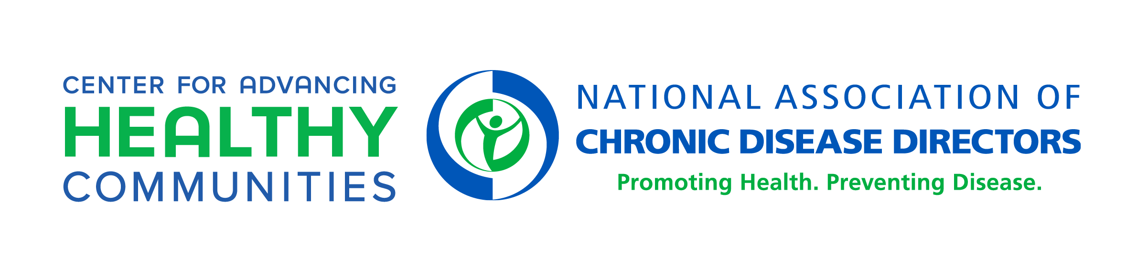
Supports to Advance Emotional Well-Being in Schools
Learning Collaborative Cohort
Final Progress Report
Due Date of Invoice: May 31, 2024

Date of Submission: Enter Date Here

Project Period Dates: Upon DocuSign of MOU – May 31, 2024

Invoice amount: $1,877.50

Deliverables to Receive Payment:

Complete End-of-Project Survey by Friday, May 10, 2024

Contact Information:

Program Contact:

NAME
TITLE
ORGANIZATION
ADDRESS LINE 1
ADDRESS LINE 2
EMAIL ADDRESS

Fiscal Contact:

NAME
TITLE
ORGANIZATION
ADDRESS LINE 1
ADDRESS LINE 2
EMAIL ADDRESS

Please submit invoice to: Heidi Milby, hmilby@chronicdisease.org

