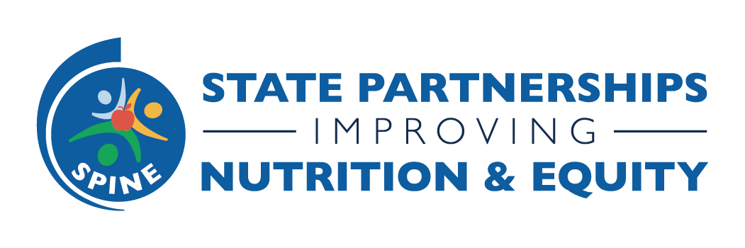

SPINE Year 2 Quarter 4 Progress Reporting Guidance
November 2023

Four new, green columns have been added to the Additional Information section of your SPINE state dashboard. The column headings and descriptions are provided below. We ask that all SPINE states complete these new columns as part of their Q4 progress reporting to help us to answer our evaluation questions for the SPINE program overall. Please ensure to input your information into the Y2 (2023) row in the Additional Information section. If you have any questions on this guidance or on Smartsheet, please feel free to reach out to Charita James, cjames_ic@chronicdisease.org.

- How helped implement, inform or improve state plan
  - This column is positioned directly after the field where you’ve listed the state plan that is being leveraged in your SPINE program.
  - In this column, please describe how the SPINE program helped you implement, inform, or improve the state plan which you initially leveraged.
- Sustaining partnerships, strategies & activities
  - In this column, please describe how your team is planning to sustain the partnerships, strategies, and activities that you initiated during the SPINE program.
- Total leveraged funds ($)
  - This column is positioned directly after the field where you’ve noted any funds that your state has leveraged or planned to leverage to support your SPINE program.
  - The purpose of this column is to capture a dollar value for total funds leveraged through the SPINE program. This will be used in aggregate across SPINE states in NACDD program evaluation and reporting.
  - To estimate your total dollar value, consider the additional guidance provided below.
  - Please ensure that any/all relevant sources of funds included in your cumulative total dollar amount are listed in the prior column, “Have you leveraged any funds?”
- What are you most proud of?
  - In this column, please highlight what you are most proud of as a result of your participation in the SPINE program. This could be a highlight of a new partnership, an innovative model, a successful outcome, or even a personal change(s).

Additional Guidance Regarding Leveraged Funds
Leveraged funds are a financial representation of resources, goods, or services from a source other than the granting organization. Leveraging funds can amplify current program efforts; help communicate the value of SPINE efforts to decision makers, partners, and community members; and help establish a foundation to sustain efforts beyond the SPINE funding period.
During Q4 of progress reporting, we ask that all SPINE states report the source(s) and a cumulative total dollar value of any funds leveraged that directly support SPINE program efforts.
What to include in Leveraged Funding
- Only include funds directly related to the implementation or evaluation of SPINE strategies.
- Funds leveraged by community partners can be included, as appropriate, if those funds are being used to support SPINE strategies.
- Only include contributions that are already obtained or received, not projected or anticipated.
- Do not include any other DNPAO-administered funds (i.e., SPAN, REACH, HOP, etc.).
- Types of contributions that should be considered include the following:
  - Federal, State, or Local Dollars (other than DNPAO funding): Funding or grants from other federal, state, or local agencies or programs.
  - Partner Contributions: Financial donation or other resource from a partner organization.
  - Grants or Private Contributions: Funds provided by a public or private organization or foundation.
  - Physical Capital or Resources: Contribution of goods or equipment. This may include space, facilities, equipment, or equipment rental. To convert a donated, in-kind event space into a dollar amount, ask what that location (or a comparable one) charges to rent, or use the following website to determine what a space would normally cost in your local area (https://www.peerspace.com/).
- Do not include additional types of contributions (e.g., volunteers, services provided in-kind, earned media, SME advisor time, donated land, events, conferences, or training, etc.).

