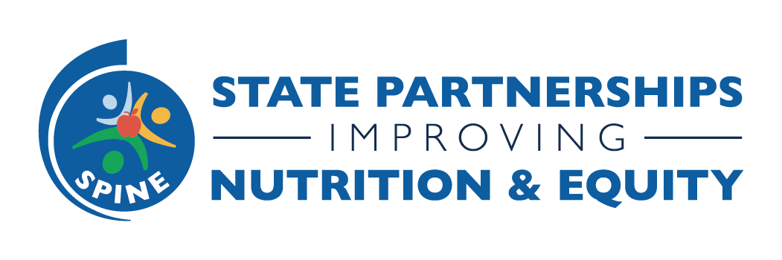
October Peer Exchange: Using Storytelling as a Tool for Sustainability
Resources

Free overall media resources- https://nccd.cdc.gov/schmc/apps/overview.aspx

Free stock images:
- African creators: https://iwaria.com/
- Black and Brown bodies: https://nappy.co/
- Disability-led
  - https://affecttheverb.com/disabledandhere/
  - https://unsplash.com/
  - https://canweallgo.com/plus-size-stock-photos/
- Latinx Photo (pan Latin America): http://www.latinphoto.org/
- LGBTQIA+: https://genderspectrum.vice.com/

For fee images: https://www.pocstock.com/

Voiceover/other resources:
- National Congress of American Indians Tribal Communications Resources: https://www.ncai.org/news/tribal-communications-resources
- People of Global Majority Voiceover List: https://www.pgmvolist.com/

For creating posts/videos and simple edits: www.Canva.com

