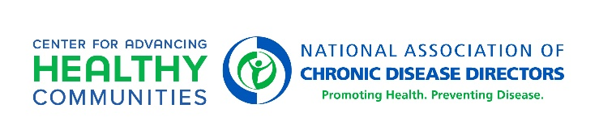

White House National Strategy on Hunger, Nutrition, and Health
Session 4: Empower All Consumers to Make and Have Access to Healthy Choices (Pillar 3)
June 15, 2023 | Resources Shared (updated 7-5-2023)

Implementation of National Strategy by Federal Agencies
https://health.gov/our-work/nutrition-physical-activity/white-house-conference-hunger-nutrition-and-health/implementing-national-strategy
PUMP Act
DOL Press Release - https://www.dol.gov/newsroom/releases/whd/whd20230202-0
US Breastfeeding Committee - https://www.usbreastfeeding.org/the-pump-act-explained.html
USDA Access to Healthy Foods in Schools, Local Food for Schools Cooperative Agreements- https://www.ams.usda.gov/selling-food-to-usda/lfs/exec-summaries
FDA “Healthy” Nutrition Claims Label
https://www.federalregister.gov/documents/2022/09/29/2022-20975/food-labeling-nutrient-content-claims-definition-of-term-healthy
CDC Food Service Guidelines Implementation Toolkit
https://www.cdc.gov/nutrition/food-service-guidelines/implementation-toolkit.html
Feeding America’s Nutrition in Food Banking Toolkit – includes Healthy Eating Research Nutrition Guidelines for Charitable Food System
https://hungerandhealth.feedingamerica.org/resource/nutrition-in-food-banking-toolkit/
Mountaineer Food Bank Procurement/Nutrition Policy (to be added)
Washington Food Service Guidelines for Department of Correction
- Executive Order 13-06 which laid the groundwork and directed the meal patterns developed by DOC/DOH
- WA State DOH-DOC Train-the-Trainer – which is what was used to train the on-the-ground staff on the meal pattern changes
- DOC 2-sided Orientation Guide – short version promotional material to communicate changes
- WA State DOH – DOC DGA food pattern document – this is what would serve as a ‘policy’ or ‘guideline’ on what food would be served on a regular basis to ensure that individuals are receiving healthy options.
Washington Special Olympics Food Service Guidelines Also available on the Special Olympics Washington website under Health Initiatives.

