Standing Rock Service Unit | Colorectal Cancer | Social Media Toolkit

 | IMAGE | MESSAGE
INTRODUCTION | 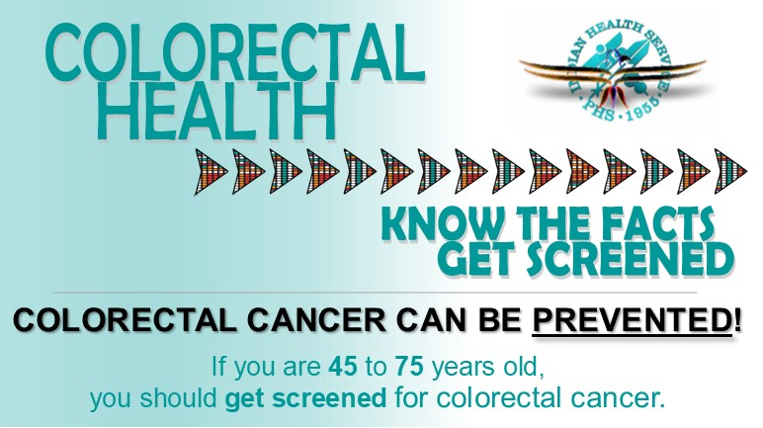 | Colorectal cancer is the second leading cause of cancer death for Native people. This cancer CAN be PREVENTED! Screening tests can find this cancer early when treatment works best. Know the facts and talk to your healthcare provider about screening for colorectal cancer as early as 45 years of age. (SRSU-Image-1)
DEFINITION | 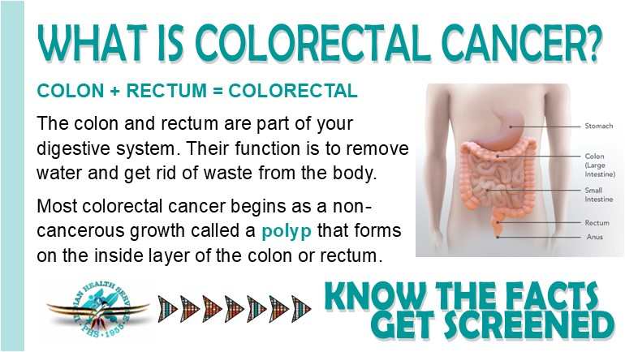 | Colorectal cancer is a disease when cells in the colon or rectum grow out of control. Sometimes abnormal growths, called polyps, form in the colon or rectum. Over time, some polyps may turn into cancer. Screening tests can find polyps so they can be removed before turning into cancer. (SRSU-Image-2)
PREVENTION | 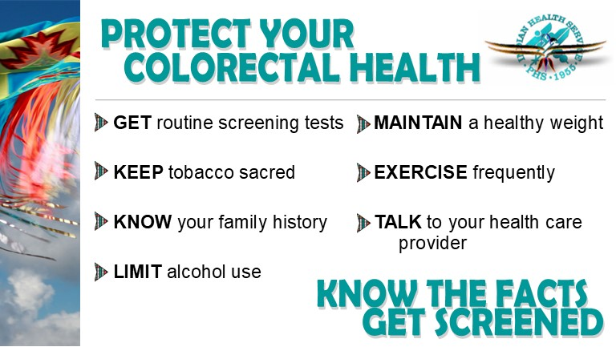 | You may be able to lower your risk of colorectal cancer by managing your diet and physical activity. Staying at a healthy weight; increasing physical activity; eating more vegetables, fruits, and whole grains; and avoiding alcohol and tobacco may help lower your risk. Getting screened regularly is one of the most powerful tools for preventing colorectal cancer. (SRSU-Image-3)
RISK FACTORS | 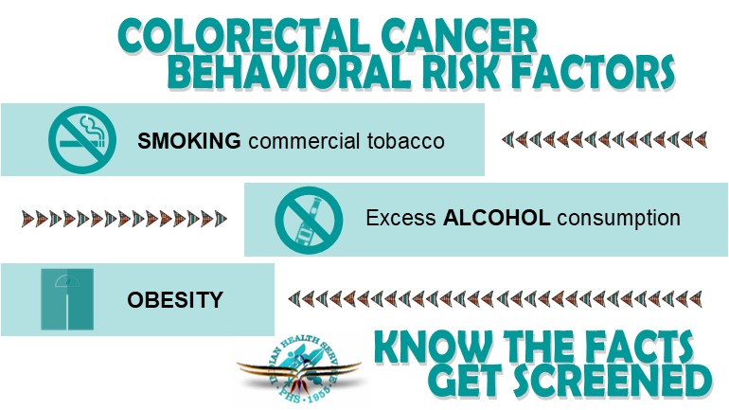 | A risk factor is anything that increases your chance of getting a disease such as cancer. Your lifestyle, diet, health conditions and family history can all play a role. While you can’t change your genetics, it may be possible to lower your risk for developing colon cancer and rectal cancer by addressing the things you can change, such as losing weight or quitting smoking. (SRSU-Image-4)
 | 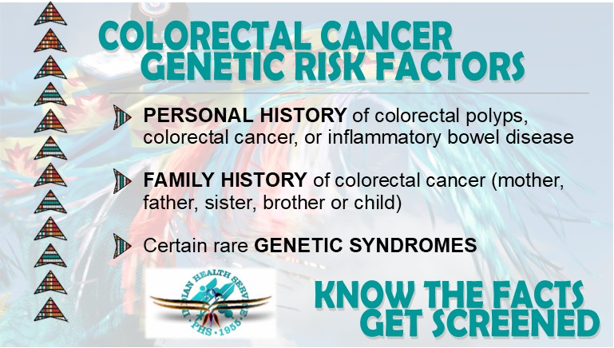 | If a family member—especially an immediate member like a parent, sibling or child—has had colon or rectal cancer, you are at a higher risk of developing cancer. It could be because you share similar genetics or are exposed to the same environment—or both. Know your family history and get screened! (SRSU-Image-5)
SCREENING | 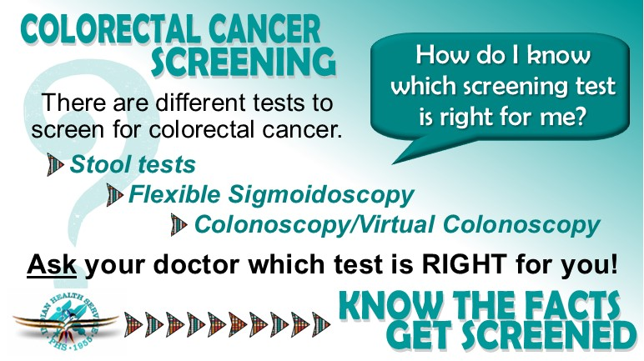 | Regular screening can actually PREVENT colon cancer by finding and removing polyps. If you’re age 45 or older, you should start getting screened for colorectal cancer. Several types of tests can be used. Talk to your doctor about which ones might be good options for you. No matter which test you choose, the most important thing is to get tested. (SRSU-Image-6)
 | 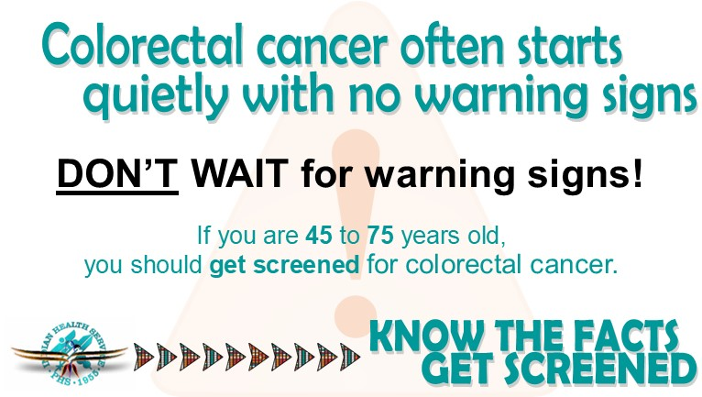 | Colorectal polyps and colorectal cancer don’t always cause symptoms, especially at first. Someone could have polyps or colorectal cancer and not know it. That is why getting screened regularly for colorectal cancer is so important. (SRSU-Image-7)

