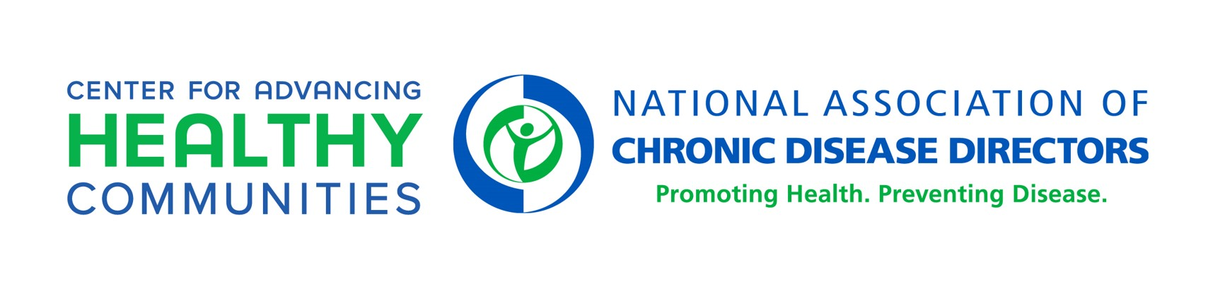
Supports to Advance Emotional Well-being in Schools
Learning Collaborative Cohort
Action Plan Template

Section 1: Action Plan Instructions
As a participating Local Education Agency (LEA) of the Learning Collaborative Cohort, you are asked to complete an action plan with your LEA team by April 30, 2022 to guide project priorities for the 22-23 and 23-24 school years. To determine goals and action steps, use your LEA assessment results and other available data, focusing on areas of needed improvement (e.g., those identified as Emerging) that are feasible to complete by the end of the project period (May 2024). Action plans should include no more than 3 goals and associated action steps. Please ensure that your action steps support the implementation of evidence-based policies, practices, and programs that support emotional well-being of students and staff. This project focuses on health equity and youth engagement, so incorporate those components throughout.

For each goal, LEA teams should include action steps to help achieve the stated goal.
- The goals should be written in a SMARTIE format - Strategic, Measurable, Ambitious, Relevant, Time-bound, Inclusive, and Equitable. Learn more about SMARTIE goals.
- SMARTIE goals are like SMART goals, with an added emphasis on inclusion and equity. This is an important distinction, as the focus of this project is to improve the health and well-being of children, adolescents, and school staff in underserved and disproportionately affected communities. See example SMART vs SMARTIE goal below:

SMART | SMARTIE
Create a youth advisory council of 10 high school students that will meet bi-monthly to guide student mental well-being efforts district-wide… | …that reflects the racial, ethnic and cultural diversity makeup of our school district student population.

Section 2: Summary of LEA Assessment

As a reminder, your LEA completed an assessment that included three components: 1) The SHAPE School Mental Health District Profile, 2) The SHAPE School Mental Healthy Quality Assessment, and 3) The NACDD Supplemental Assessment. See a summary below of the top domains where your LEA Assessment demonstrated an opportunity for growth. For more information or to focus on additional areas, please refer to the LEA Assessment summary materials located in our shared Google Drive.

Top Areas of Opportunity for School District

CATEGORY | DETAILS

Where do I start?
- Start with the areas that are identified as “Emerging” (SHAPE System) or where you rated your district a 0 or 1 (NACDD Supplemental Assessment).
- To prioritize, begin to identify areas that 1) are feasible for your team to implement, 2) support the sustainability of your school mental health efforts, 3) advance health equity, and 4) are meaningful to your district and the students you serve.

NACDD recommends that you focus on improving infrastructure and systems to set your district up for long-term success. This could include strengthening areas such as policies, procedures and other district systems, district- and school-level teams, and the use of data to target programs and measure impact.

Section 3: Action Plan Template

Goal #1: Click here to enter Goal #1 in SMARTIE format, including the target audience.

Action Steps (to include timeline):  What will be done? | Benchmarks  How will you know you are successful? What outcomes do you expect to see? | Responsible Party:  Who will do it? | Timeline  By when will it be done? | Resources  What resources are available or needed?  Consider resources such as financial, human, political, etc. Ensure evidenced-based resources to the extent possible. | Notes
Action Step 1.1:
By (insert month/year), enter action step here (row will expand)
Action Step 1.2:
By (insert month/year), enter action step here (row will expand)
Action Step 1.3:
By (insert month/year), enter action step here (row will expand)
Action Step 1.4:
By (insert month/year), enter action step here (row will expand)
Action Step 1.5:
By (insert month/year), enter action step here (row will expand)

Goal #2: Click here to enter Goal #2 in SMARTIE format, including the target audience.

Action Steps (to include timeline):  What will be done? | Benchmarks  How will you know you are successful? What outcomes do you expect to see? | Responsible Party:  Who will do it? | Timeline  By when will it be done? | Resources  What resources are available or needed?  Consider resources such as financial, human, political, etc. Ensure evidenced-based resources to the extent possible. | Notes
Action Step 2.1:
By (insert month/year), enter action step here (row will expand)
Action Step 2.2:
By (insert month/year), enter action step here (row will expand)
Action Step 2.3:
By (insert month/year), enter action step here (row will expand)
Action Step 2.4:
By (insert month/year), enter action step here (row will expand)
Action Step 2.5:
By (insert month/year), enter action step here (row will expand)

Goal #3: Click here to enter Goal #3 in SMARTIE format, including the target audience.

Action Steps (to include timeline):  What will be done? | Benchmarks  How will you know you are successful? What outcomes do you expect to see? | Responsible Party:  Who will do it? | Timeline  By when will it be done? | Resources  What resources are available or needed?  Consider resources such as financial, human, political, etc. Ensure evidenced-based resources to the extent possible. | Notes
Action Step 3.1:
By (insert month/year), enter action step here (row will expand)
Action Step 3.2:
By (insert month/year), enter action step here (row will expand)
Action Step 3.3:
By (insert month/year), enter action step here (row will expand)
Action Step 3.4:
By (insert month/year), enter action step here (row will expand)
Action Step 3.5:
By (insert month/year), enter action step here (row will expand)

