General Instructions
- Go to the SPINE Project Management Hub and Select your State.
- You will be prompted to log in to yourSmartsheet account if you have not already.
- Look on your state dashboard for the Quarterly Progress Report reports (indicated by the green arrows below) to document your progress from the past quarter in each section. Specific guidelines for each section are described on the pages that follow.
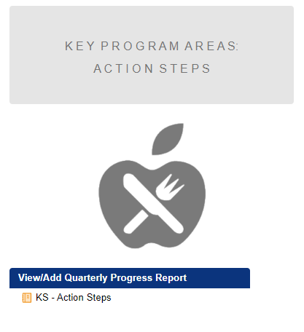
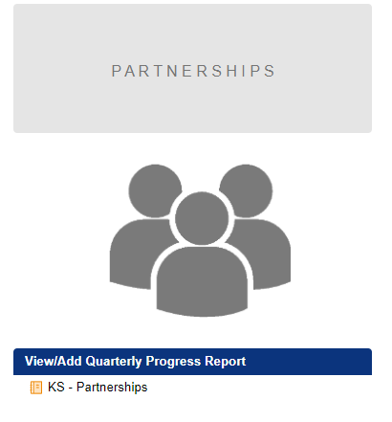

- Progress reporting columns throughout all sections are color coded to help users find and focus on the necessary columns for a given quarter.
  - Q1 pink – January 1 – March 31
  - Q2 green – April 1 – June 30
  - Q3 blue – July 1 – September 30
  - Q4 yellow – October 1 – December 31
- Throughout your progress reporting, be sure to save your changes often so they are not lost.
- After you save your changes in each section, use the back button on your browser to return to your state dashboard page. Use your state dashboard page as the entry point for all sections.
- Any guidance highlighted in YELLOW is updated for Q3

Background Information
For this section, the “[Your State] Background Information” link under the “View/Update Background Information” blue text box will open into spreadsheet view with the previously submitted data on each partnership in columns across each row.
- Please review the information captured in these fields and update content, as needed, based on your experience and activities of the past quarter.
- If there are any changes to the information in this section (Estimated Reach, How you are estimating reach, How you are addressing inequitable food/nutrition security, and/or How you are integrating health equity), you can update this information by double clicking the cell and editing the existing text (e.g., “In Q1, we initiated the following…”).
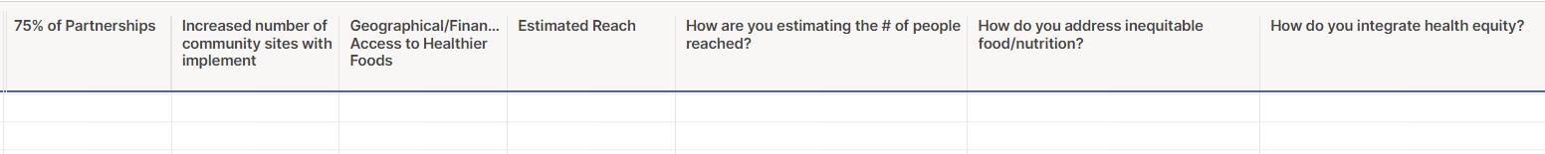
Key Program Areas Action Steps
For this section, the “[Your State] Action Steps” link under the “View/Add Quarterly Progress Report” blue text box will open into spreadsheet view with the previously submitted data in columns across the first row.
- Tab across to find and update the color-coded columns for the past quarter.
- For each of the Action Steps in your plan, please provide any progress updates in the relevant Quarter’s (Q1, Q2, Q3, Q4) “Sub Action Step Progress” column. In your update, please include:
  - The Current status of action step: Not Started, In progress, Completed
  - Any activities that have taken place that show progress towards completion of action step
  - How you incorporated and operationalized equity from your action plans into these activities
  - Activities/Accomplishments you would like to highlight
- If the activity is not yet started, we do not expect to see anything in the “Actual Output” column for that Action Step. If an activity is In Progress or Completed, please fill in the Actual Output column, considering what you had entered in the Expected Output column.
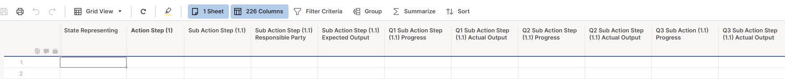

Partnerships
For this section, the “[Your State] Partnerships” link under the “View/Add Quarterly Progress Report” blue text box will open into spreadsheet view with the previously submitted data on each partnership in columns across each row.
- Tab across to find and update the column for the relevant quarter.
- For each of the Partner Names, please provide any progress updates in the “Enter Any Progress Notes” column for the relevant Quarter. In your update, please:
  - Describe progress in planned partnership activities and if efforts may have pivoted
  - Describe how these activities influence PSE changes for the relevant quarter, if any
  - Indicate if any changes have taken place in their partnerships (e.g., roles, intended activities, etc.)
  - NOTE: Please take the time to fully complete this section. In addition to inputting the current status of your partnerships, we request that you please input the additional information requested above.

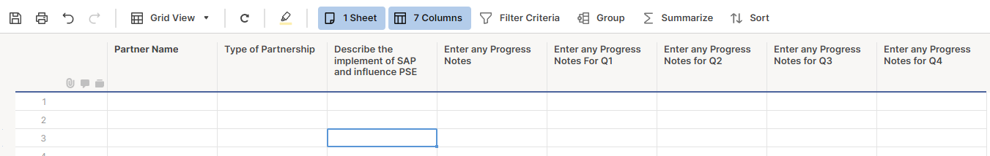
Additional Information
For this section, the “[Your State] Additional Information” link under the “View/Update Additional Information” blue text box will open into spreadsheet view with the previously submitted data on each partnership in columns across each row.
- Please review the information captured in these fields and update content, as needed, based on your experience and activities of the past quarter.
- If there are any changes to the information in this section (Challenges/Barriers, Ways that you addressed challenges/barriers, State-level plan, and/or Leveraged funds), you can update this information by double clicking the cell and editing the existing text (e.g., “In Q1, we experienced the following challenge…”).
Attachments
- If you are funded to conduct Breastfeeding-related activities, please upload the completed SPINE BF Progress Report Guidance and Template for Q3 in this section
- Breastfeeding Reporting Guidance
- If you have any documentation to share relevant to your SPINE Progress Reporting, please click on the “Attachments” button (paperclip image) at the bottom of your state dashboard page. This will open a short form where you can describe and attach one or more documents.
- Attachments can be uploaded to the SPINE Project Management Hub at any time. Please feel free to upload press releases, news stories, media features, presentation slide decks, photos, videos, etc. that highlight your SPINE efforts.

