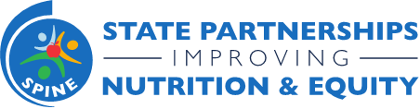
State Partnerships Improving Nutrition & Equity Program
Monthly Update Call with States
April 19, 2022 3:00-4:00 pm ET
Join Zoom Meeting: https://chronicdisease.zoom.us/j/86755367312
Meeting ID: 867 5536 7312

Attendees: All NACDD SPINE Team Members and All SPINE State Leads.

Purpose: To provide ongoing support and information, program reminders and announcements, and an open forum for Q&A.

3:00-3:05 pm | Welcome, housekeeping, meeting norms | Charita
3:05-3:10 pm | Opener | Patrilie
3:10-3:25 pm | SPINE Special Breastfeeding Project Share-out | SPINE States
3:25-3:30 pm | Upcoming T/TA Opportunities | Charita
3:30-3:40 pm | Review Quarter 1 Invoicing | Crystal
3:40-3:50 pm | Q&A/Reviewing T/TA Topics that were brought up during 1:1 meetings | Patrilie
3:50-4:00 pm | Reminders & Closing | Charita

