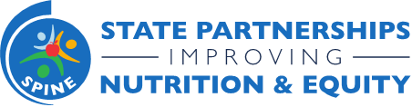
State Partnerships Improving Nutrition & Equity Program
Monthly Update Call with States
March 15, 2022 3:00-4:00 pm ET
Join Zoom Meeting
Meeting ID: https://chronicdisease.zoom.us/j/86755367312

Attendees: All NACDD SPINE Team Members and All SPINE State Leads.

Purpose: To provide ongoing support and information, program reminders and announcements, and an open forum for Q&A.

3:00-3:05 pm | Welcome, Housekeeping, Meeting Norms
3:05-3:15 pm | Opener
3:15-3:25pm | Review upcoming events, deliverables, etc:  - SPINE State Internal Hub  - Training & Technical Assistance Page  - SPINE Project Management Hub
3:20-3:40 pm | Finalizing your SAP & Progress Reporting
3:40-3:50 pm | Q&A
3:50-4:00 pm | Closing & Next Steps  - Important Dates to Remember  - General Feedback Form Overview

