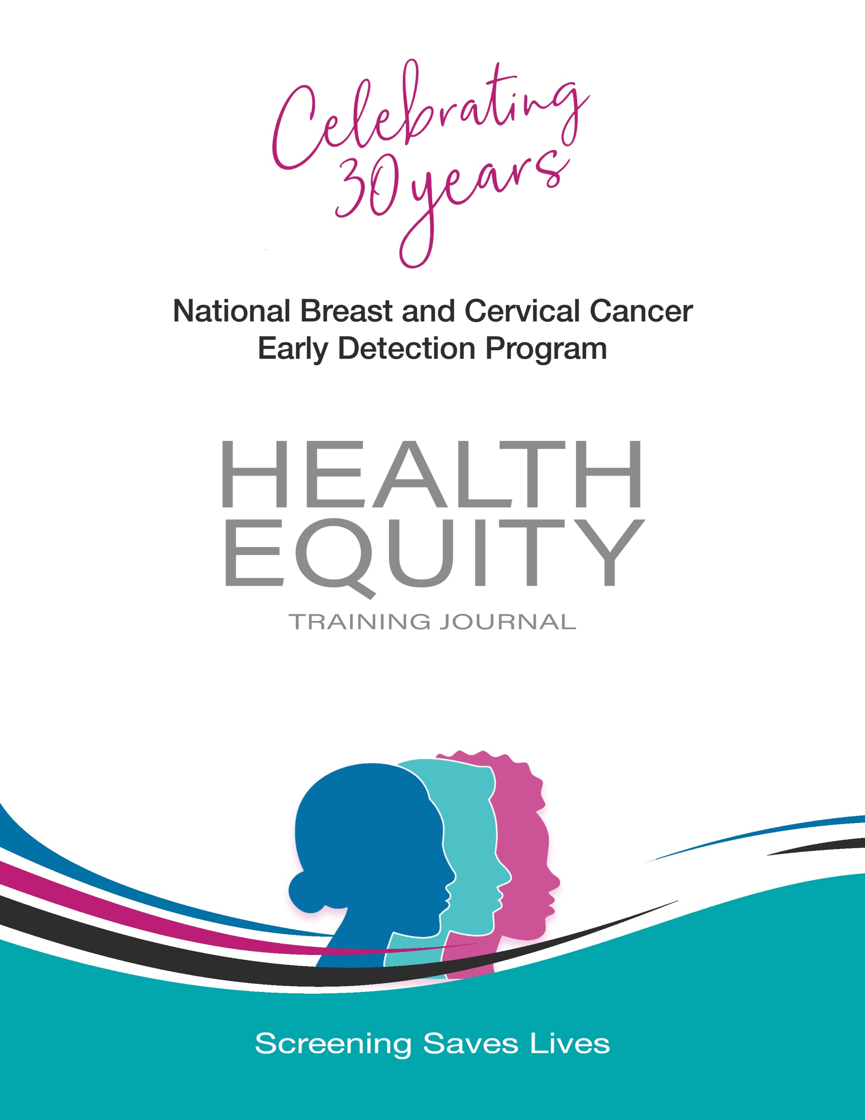
Part 3: The Social Intersections of Health

This journal was authored by the National Association of Chronic Disease Directors.
Contributing Authors:
Zunera Mirza, Tiffany Pertillar, Robyn Taylor, Gwendolyn A. Williams

The “Enhancing Cancer Program Grantee Capacity through Peer-to-Peer Learning” project is supported by the Centers for Disease Control and Prevention of the U.S. Department of Health and Human Services (HHS) as part of a financial assistance award totaling $850,000 with 100 percent funded by CDC/HHS. The contents are those of the author(s) and do not necessarily represent the official views of, nor an endorsement, by CDC/HHS, or the U.S. Government.

Part 3: The Social Intersections of Health

Now that we have laid the foundation for this work and you have spent time unpacking, discovering, and challenging yourself, we will dig deeper into the social factors that intersect with and have the capacity to impede health. Social factors that will be discussed in this section are housing, the built environment, and the resulting impact on transportation access and other factors that influence health. We will begin to explore social contexts and their intersection with the health of communities.

3.1 Health and Housing
Time Needed: 45 minutes
The health of a person is intrinsically linked to their housing status. When families have access to stable, affordable housing in safe communities with access to public transportation, grocery stores, and other amenities, they have greater potential for better health outcomes. However, many of the people we aim to serve do not live in these conditions. Why is that? Have you ever wondered how communities got to be the way that they are? What causes some communities to thrive and other communities to struggle? And what does that have to do with a person’s health?
This week, we will explore the intersection of health and housing. Recall that one step toward equity is acknowledgment of and reckoning with the past. That sometimes requires that we unlearn what we have been taught so that we can make room for empathy and a better understanding of communities’ unique experiences, challenges, and assets. This empathy and understanding encourages engagement with those communities to affect change and health improvement.
Watch:
Does My Neighborhood Determine My Future? (https://www.youtube.com/watch?v=pu2sKNJMH-k) (Time: 30 minutes)
Watch:
Where You Live Has a Huge Impact On Your Health (https://www.youtube.com/watch?v=zNzFnHL-8Zk) (Time: 9 minutes)

Reflect:
- Look at the community where you live or work. What services are available to you? What services are missing? Is there evidence of detrimental impacts of long-standing housing policies and practices?
Click in the box to start typing.

Resonance:
An Instance of Challenge:
Click in the box to start typing.

An “Aha!” Moment:
Click in the box to start typing.

An Inspiration:
Click in the box to start typing.

Going Deeper: To explore the intersection of health and housing further, watch Segregated by Design (https://www.segregatedbydesign.com/) (17:40 minutes).

3.1 Health and the Built Environment
Time Needed: 45 minutes
The built environment is another major influencer of health. Communities with access to various modes of transportation, such as walking, running, biking, and public transit, are healthier. However, Black, Hispanic, other racialized communities, LGBTQ communities, and people with disabilities in both rural and urban settings tend to have restricted access to safe transportation as well as limited access to economic opportunities. The needs for these populations are different from those of other groups that we serve, so how we address them requires new approaches, new partners, and concerted efforts.
Listen: Health to be Determined: Using Built Environment to Relieve Communities from Arrested Mobility by Charles T. Brown, MBA (https://chronicdisease.org/health-to-be-determined-using-built-environment-to-relieve-communities-from-arrested-mobility/) (Time: 32:48 minutes)

Reflect:
1. How might the concept of Arrested Mobility impact the health of people living in the communities you serve?
Click in the box to start typing.

2. Many health challenges are directly related to transportation, land use patterns, infrastructure, and accessibility. How can public health professionals influence the design of communities to promote optimal health for all? For example, can you use your power or connections to influence bus routes to increase access to healthcare?
Click in the box to start typing.

Resonance:
An Instance of Challenge:
Click in the box to start typing.

An “Aha!” Moment:
Click in the box to start typing.

An Inspiration:
Click in the box to start typing.

Going Deeper: To explore the intersection of health and the built environment further, review Why the Built Environment? (https://www.youtube.com/watch?v=vL4VPMYmTUw)
Suggested time allocation: 15 minutes

Next Steps

You have done a lot of work over the last few weeks. In Part 1, we laid the groundwork to give us a laser focus on the social determinants of health and to provide support for intentionally addressing racism along with other upstream root causes of inequity. In Part 2, we challenged you to unpack your own biases by examining your thoughts, beliefs, and attitudes about social identity groups and to consider how they may impact your work. In Part 3, we explored the intersection of health and the social determinants of health such as housing and transportation. We hope that you found this work enlightening and rewarding!
So, we ask that you complete the statement below again.
Health equity is important to me because:
Click in the box to start typing.

How has your statement changed since the beginning of the journey?
Whether this journal has been a refresher for you or your starting point, get ready to go further. The work is not done yet! We have more to learn, more to unpack, and more to explore. We will travel this journey together and it is just beginning. The next stop is the 30th Anniversary of the National Breast and Cervical Cancer Early Detection Program virtual event October 6 and 7, 2021. There is where we will explore strategies to address some of the inequities that we have learned so much about. In preparation for the meeting, review these resources.
- National Breast and Cervical Cancer Early Detection Program and Health Equity Strategies: Working toward Health Equity (https://www.cdc.gov/cancer/nbccedp/pdf/nbccedp-health-equity-strategies-508.pdf)
- National Breast and Cervical Cancer Early Detection Program: Writing Effective Objectives (https://www.cdc.gov/cancer/nbccedp/pdf/smartie-objectives-508.pdf)
- Health Equity Guiding Principles for Inclusive Communication (https://www.cdc.gov/healthcommunication/Health_Equity.html)
Begin to think about and make note in your journal how you might implement strategies in your program. Put these tools in your virtual luggage, along with your journal, and bring them to the meeting.

