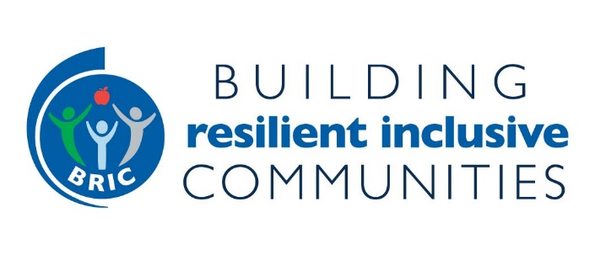
SOCIAL CONNECTEDNESS RESOURCES
(updated 8/3/2021)

Potential Partner Organizations
These are organizations that could serve as state and/or local partners.
- Mental Health America. The nation’s leading community-based nonprofit dedicated to addressing the needs of those living with mental illness and promoting the overall mental health of all. Search Mental Health Affiliate for your state contact
- American Health Care Association and National Center for Assisted Living. Largest association in the United States representing long term and post-acute care providers, with more than 14,000 member facilities. State Affiliate Directory.
- National Alliance for Mental Illness (NAMI). The nation's largest grassroots mental health organization dedicated to building better lives for the millions of Americans affected by mental illness. State NAMI Affiliate Directory.
- Administration for Community Living. Supports older adults and individuals with disabilities across a variety of services, divides the country into 10 regions.
- National Association of Area Agencies on Aging (n4a). A membership association representing America’s national network of 622 Area Agencies on Aging (AAAs) and providing a voice in the nation’s capital for the more than 250 Title VI Native American aging programs. Find the AAA or Title VI program in your area.

CDC RESOURCES
These resources will help better understand some of the issues related to social connectedness and loneliness.
- How Right Now. Soon to be housed at CDC’s Division of Population Health, How Right Now is an initiative to address people's feelings of grief, loss, and worry during COVID-19 and links to support resources for individuals and families.
- DPH’s Alzheimer’s Disease and Health Aging. A feature story, Loneliness and Social Isolation to Serious Health Conditions, on the CDC Alzheimer’s Disease and Healthy Aging, Communications Center web page.
- CDC Mental Health and Coping. An article on the CDC COVID-19 webpage, Coping with Stress, that was updated on January 22, 2021 and provides information on healthy ways to cope with stress, mental health and crisis, and helping others cope.
- DPH’s Tribal Practices for Wellness in Indian Country (TPWIC). Information located on the CDC Healthy Tribes webpage that discusses the mission of TPWIC and provides information on cultural connectedness.
- CDC’s Injury Center. Connectedness for suicide prevention and strategies and resources available through the CDC Injury Center webpage.

- Division of Adolescent and School Health (DASH). Information on protective factors (individual or environmental characteristics, conditions, or behaviors that reduce the effects of stressful life events) including Adolescent Connectedness, Parent Engagement in Schools, Positive Parenting Practices and School Connectedness.

Recent Publications and Reports on Social Connectedness
Links to help generate ideas and approaches in your state.
- “Socially Connected Communities: Solutions for Social Isolation”. A report from Healthy Places By Design, with companion “Action Guide for Local Government and Community Leaders”.
- Coalition to End Social Isolation and Loneliness. Collection includes information on how various organizations (in the US and other countries) are addressing social isolation.
- “The Health Care System is an Untapped Resource in Combating Social Isolation and Loneliness in Older Adults”. An article from Health Affairs that emphasizes the importance of a community-wide and systems approach
- “Addressing Social Isolation and Loneliness Lessons from Around the World”. Lessons learned from the Commonwealth Fund that apply to BRIC:
- Identify a shared interest around which to bring older adults together, taking a community-wide approach
- Identify policy supports to sustain programs, e.g., including policies within State Plan on Aging
- Bolster existing community systems that serving older adults such as Meals on Wheels.
- “Together Apart: Findings from the Social Isolation Impact Summit”. This report from Milken Institute presents the results of the Social Isolation Impact Summit held in July 2020 providing 12 takeaways and examples of state plans on aging and other state strategies, closing with a Call to Action.
- “Effect of Layperson-Delivered, Empathy-Focused Program of Telephone Calls on Loneliness, Depression and Anxiety Among Adults During the COVID-19 Pandemic”. RCT of 240 older adults receiving services through a Meals on Wheels organization also participated in a 4-week empathy-oriented telephone program delivered by rapidly trained lay callers during the coronavirus disease pandemic resulting in improved loneliness, depression, anxiety, and general mental health.

Social Connectedness - Policy, Systems and Environmental Change Approach
For BRIC, we are looking at policy changes and ways to connect systems community-wide that address social isolation within older adults such as joint training on social isolation within and across sectors working, strengthening linkages between public health system and community-based organizations or adding a social connectedness component to your nutrition security or physical activity PSE. As with many issues, what we do know is that not one sector can solve the issues alone. We will continue to build information in this area for BRIC states.

