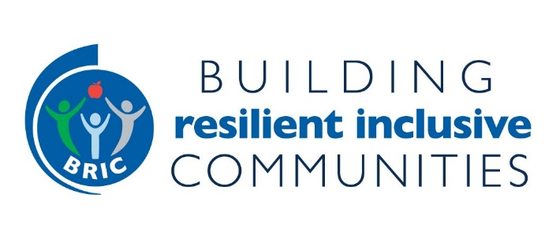
HEALTH EQUITY RESOURCES AND PUBLICATIONS
(updated 6/21/2021)

Recently Added
New Diversity and Equity Resources from the National Aging and Disability Transportation Center. The National Aging and Disability Transportation Center has compiled a resource hub with collection of articles, reports, webinars and more.

General Public Health and Racial Equity
Government Alliance on Race and Equity (GARE) has developed a number of resources to help local governments center health and racial equity, and potential relationship/partnership.

  - GARE works with local and regional jurisdictions across the country. Look for members in your state. https://www.racialequityalliance.org/where-we-work/jurisdictions/

  - Racial Equity – Getting to Results. https://www.racialequityalliance.org/resources/racial-equity-getting-results/

  - Racial Equity Toolkit: An Opportunity to Operationalize Equity. https://racialequityalliance.org/wp-content/uploads/2015/10/GARE-Racial_Equity_Toolkit.pdf

  - Racial Equity Action Plans: A How-to Manual – toolkit for local governments to develop their own Racial Equity Action Plan as both a process and outcome.
https://www.racialequityalliance.org/wp-content/uploads/2016/11/GARE-Racial-Equity-Action-Plans.pdf

Equitable Processes Lead to More Equitable Outcomes. Blog from Phil Bors with Health Placed by Design emphasizing equitable process must address who is included and how they are engaged and for what purpose. Phil provides links to “Equity Advancing Resources”. Note: All of the Resources mentioned in the blog article are on BRIC States webpage Resources Section. https://healthyplacesbydesign.org/equitable-processes-lead-to-more-equitable-outcomes/

National Association of Chronic Disease Directors – Race Toward Health. NACDD’s Health Equity Council launch 'Race Toward Health' Podcast Launch, Webinars, and Peer to Peer Activities to Support National Minority Health Month. https://chronicdisease.org/tag/race-toward-health/

Color of Law. NACDD Presents: The Color of Law presentation and panel discussion with Author Richard Rothstein, Dr. Susan Kansagra, Robyn Taylor and Chip Allen. RECORDING
A great precursor to reading The Color of Law and watching the webinar recording is a short video ‘Segregated By Design’ which examines the forgotten history of how our federal, state and local governments unconstitutionally segregated every major metropolitan area in America through law and policy.

CDC’s Office of Minority Health, Health Equity Portal – Dedicated to racism and health. https://www.cdc.gov/healthequity/racism-disparities/index.html
CDC Health Equity Resources including COVID-19 health equity resources. https://www.cdc.gov/healthequity/index.html

Data and Health Equity
County Health Rankings – search county level data related to the health of communities. State reports available.

County Health Rankings – Track which cities and counties have declared racism as a public health crisis. https://www.countyhealthrankings.org/racism-as-a-public-health-crisis-three-responses

CARES - Center for Applied Research and Engagement Systems allows you to map 80+ health-related indicators for a community and generate a Community Health Needs Assessment Report. https://engagementnetwork.org/map-room/
CARES Spark Map

Community Commons (The Commons) is a platform that community collaboratives and coalitions can access to map data and identify community resources and tools related to various topics including health equity.

HEALTH EQUITY AND FOOD SYSTEMS
Racial Equity Tools for Planning Food Systems – University of Wisconsin developed a Food System Racial Equity Assessment Tool and facilitation guide.
HEALTH EQUITY IN PLANNING & TRANSPORTATION
Ensuring an Equitable Approach to Rebalancing Streets, 14 Strategies to Manage Change
with Ethics, Equity, and Empathy. In response to COVID-19, communities rebalanced public space on streets and roadways to provide greater opportunities to walk, roll, and use transit, both to enable social distancing and to promote healthy, active travel. For planners, designers, and other transportation professionals.

12 Strategies for Centering and Prioritizing Health Equity in Transportation. Charles Brown, Equitable Cities, provides guidance for meaningful discussion to move equity from a buzzword to a process and outcome in planning and transportation.

Pandemic Toolkit: Manual for Rebuilding Community Health and Opportunity Post COVID-19. Provides list of 20 rapid strategies (mostly policy, zoning in nature) in response to COVID-19 and beyond such as pop-up bike lanes, open complete streets, and implementing the U.S. National Association of City Transportation Officials (NACTO) Streets for Pandemic Response and Recovery.

The Toolkit for Health, Arts, Parks and Equity. From The Trust for Public Land, in collaboration with NACHO (in response to coronavirus pandemic) to create this toolkit using place-based arts and culture to achieve health equity. Includes section on various case studies across the country along with guiding principles. Main audience is local county public health departments.

Long-Range Planning for Health, Equity & Prosperity- A Primer for Local Governments. From ChangeLab Solutions, for planners at city and regional level, applies to urban and rural communities, to prioritize health and equity in their work.

Charles Brown’s Rutgers Grad Students Work focusing on Complete Streets and Crime Prevention through Environmental Design

Moving Beyond the Aesthetics and Pageantry of Equity and Inclusion in Transportation. Charles Brown with Equitable Cities explores the intersection of artists and transportation and their “intentional collaboration” for community healing and “co-powering”.

