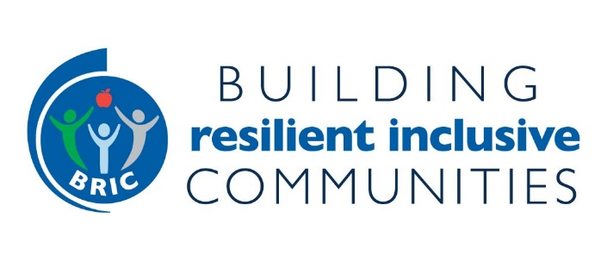
ENGAGING COMMUNITIES - RESOURCES, PUBLICATIONS, WEBINARS
(updated 4/1/2021)

Planner’s Playbook (from ChangeLab Solutions)

Community Engagement Almanac
The Community Engagement Guide to Sustainable Communities

Statewide Walkability Action Institute
Walkability Action Institute | National Association of Chronic Disease Directors

Virginia Walkability Action Institute
VWAI-Application-Overview_2021.pdf (vml.org)
https://www.youtube.com/watch?v=XQnrwv1bBVM - Virginia centered health equity and racial equity

Active Communities Tool Guide and Assessment Modules
Active Communities Tool | Physical Activity | CDC

Four Shifts to Heal Communities (Prevention Institute)
Four-Shifts-to-Heal-Communities_Report_112020.pdf (preventioninstitute.org)

Long-Range Planning for Health, Equity & Prosperity- A Primer for Local Governments
Long-Range Planning for Health, Equity and Prosperity

Charles Brown’s Grad Students Work on leveraging anchor institutions, specifically planning programs to help underserved communities
Trenton Reconnected.mp4

Pandemic Toolkit: Manual for Rebuilding Community Health and Opportunity Post COVID-19
https://spark.adobe.com/page/a66lYPnBiZ8zs/

Equitable Processes Lead to More Equitable Outcomes
https://healthyplacesbydesign.org/equitable-processes-lead-to-more-equitable-outcomes/

The Toolkit for Health, Arts, Parks and Equity (from The Trust for Public Land)
https://www.tpl.org/the-toolkit-for-health-arts-parks-and-equity

Partnership Building Tools

The Partner Toolkit – step by step partnership building process with tools in Appendix from the Partnering Initiative
https://thepartneringinitiative.org/wp-content/uploads/2014/08/Partnering-Toolbook-en-20113.pdf

The Partnership Accelerator – another step by step partnership building process with tools in Appendix
https://www.thepartneringinitiative.org/wp-content/uploads/2020/07/SDG-Partnership-Guidebook-1.0.pdf

Association of State Public Health Nutritionists Partnership Building Webinar Part 1 - The
Power Balance Equation in Partnerships & Coalitions: When, What and How
https://asphn.org/partnership-development-training-series-part-1/

