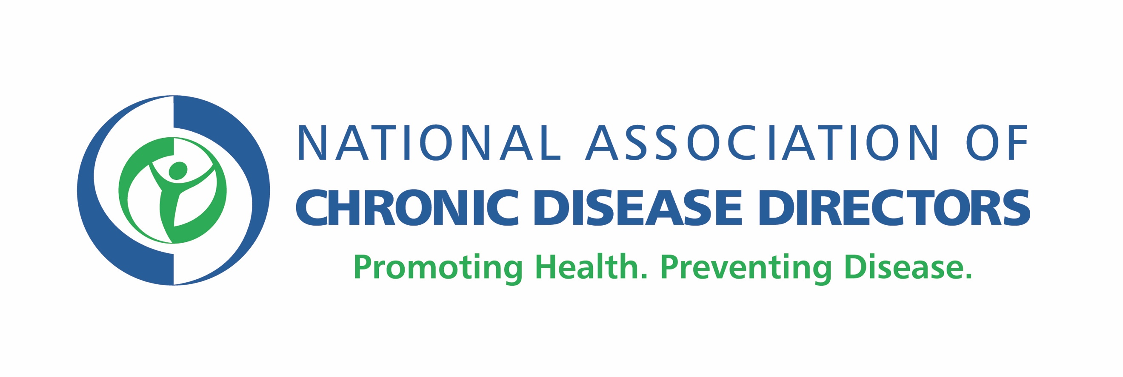
Release Form
(Last Revised: July 2019)

I, _____________________________ (print name), give permission to the National Association of Chronic Disease Directors (“NACDD”) to use the footage from ______________________ (describe footage) for the following purposes:

- Use any excerpt of the footage provided, including, but not limited to: still photograph(s), audio, or transcription of audio, or to otherwise edit and/or reproduce the footage provided in NACDD videos, podcasts, or other multimedia projects in perpetuity and throughout the world in any medium, now known or later developed.

I understand and agree that NACDD may use this footage without warrantee, obligation, or payment of royalties.

I understand NACDD makes no warranties or promises and is not responsible for any unauthorized use of the footage.

I understand that NACDD will own the copyright to the materials wherein the footage appears in connection with NACDD-sponsored activities.

If the above terms and conditions of this Release are acceptable to you, please complete sign and date this form.

__________________________________ (signature)

____________________________________ (Job title)

_____________________________________ (Organization)
______________ (date)

By signing this document, you warrant that you are a representative of your organization able to release footage and extend permissions in the manner described above.

****
NACDD staff or representative collecting this form should complete the below information and send to NACDD Communications at publications@chronicdisease.org within three business days of completion.
Form collected by:_______________________________________
Date:_____________________
Location:_________________________________
Event:____________________________________
Associated materials (i.e., photos, video, audio recording):_________________________________

