Additional Online Communications Tools and Resources
The Communications Department has compiled a list of royalty-free or open-source graphics, images, and audio databases and resources to support your communications projects.
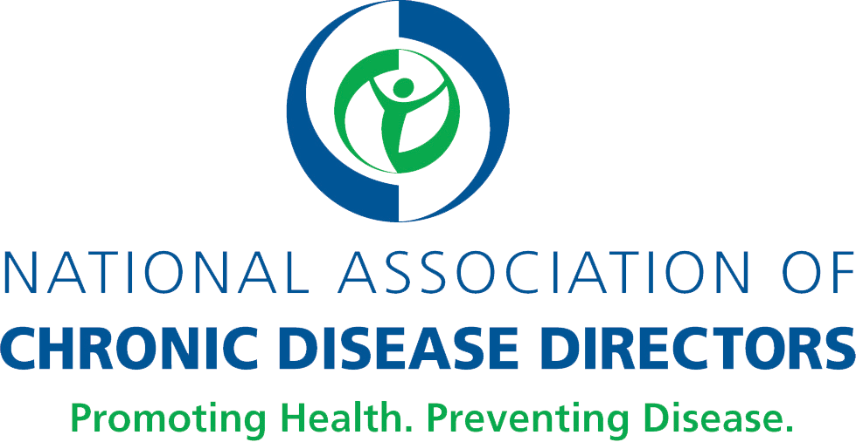

Stock images
- Stock.XCHNG (freeimages.com): Has more than 50 pages of pharmacy-oriented healthcare photos.

- Pexels (pexels.com): Various photos and videos for free.

- Dreamstime (dreamstime.com): Has more than 15,000 health care photos that emphasize natural health and healthy living.

- Unsplash (unsplash.com): High-resolution photo collections that highlight healthy foods, health, fitness, and wellness.

- ShotStash (shotstash.com): Various photos for free.

- StockSnap.io (stocksnap.io): High-resolution photos that focus on landscape, outdoors and exercise.

- CDC’s Public Health Image Library (phil.cdc.gov/phil/home.asp): Includes images of influenza, natural disasters, environmental health, bioterrorism, everyday activities, EM imagery, health behaviors, public health in action, laboratory science, and developmental milestones.

- National Eye Institute (NEI) Media Library (medialibrary.nei.nih.gov): A multimedia collection with a variety of engaging, scientifically accurate images and videos about eye health.

- Trans/non-binary health from Vice Media (broadlygenderphotos.vice.com): A free stock library of images of trans and non-binary models, including a health section.

- Nappy (www.nappy.co) High-res photos of Black and brown people.

Vector art/graphics
- Vecteezy (vecteezy.com): Vector images allow for more flexibility because they can be resized without losing sharp resolution.

- The Noun Project (thenounproject.com): A collection of 1000+ icons, mostly black and white

- Font Awesome (fontawesome.com): Has icons for free or pay.

Audio libraries
- YouTube Audio Library (youtube.com/audiolibrary/music): YouTube Audio Library has different types of audio files, ranging from background music to sound effects.

- Free Stock Music (freestockmusic.com): Audio files include cinematic music, easy listening, and other categories such as classical and corporate.

Graphic design tools
- Canva (canva.com): Canva allows users to use drag-and-drop features and professional layouts in design graphics.

Color resources
- Adobe Color wheel (color.adobe.com/create): Shows color palettes based on a color you choose

- Color Image Search (labs.tinyeye.com): Search for a color and creative commons images that use the same color.

Fonts
- Google Fonts: fonts.google.com
  - Which google fonts work together: The art of mixing typefaces
- Adobe: (fonts.adobe.com)
- Font Awesome (fontawesome.com): Has lots of fonts and icons for free or pay.

Accessibility

- W3C Accessibility guide (w3.org/standards/webdesign/accessibility): A collection of guidelines for creating disability-conscious web designs.

- WebAim Contrast Checker (webaim.org/resources/contrastchecker): Evaluates contrast and color for accessibility.

