Welcome to EEC!
EEC Members | Please be sure to enter the First Name_Last Name (State) to the Chat for all members of your party so we can track attendance. For example MaryCatherine Jones (NACDD)
EEC Leads | Shelby Vadjunec (WI), Shelby.vadjunec@dhs.wisconsin.gov  Emily Peterson Johnson (TX), Emily.johnson@dshs.texas.gov  Julie Cleaton (AK), julie.cleaton@alaska.gov  April Hendrickson (CO) AMP Liaison, April.hendrickson@state.co.us
NACDD Consultants | MaryCatherine Jones, mcjones@chronicdisease.org  Hannah Herold, hherold@chronicdisease.org
Date | April 8, 2020
Time | 11am PT/12pm MT/1pm CT/2pm ET
Objective | A BREAK FROM THE NEW NORMAL?
Dress Code | Unshaved faces, anti-wrinkle face masks and pajamas welcome! We know there will be dogs and kids around, so please mute your line when you are not speaking.

Agenda Item | Discussion | Actions
Welcome, Housekeeping and Polls  3 minutes  Shelby | *The agenda being shared on screen is updated from the one that was sent with the appointment. You may access the current agenda in the chat.  Please enter your First Name, Last Name and State abbreviation into the Chat so we know who’s here.  Our newest EEC Lead, Julie Cleaton, is co-facilitating with us this month! Welcome, Julie!  Today we have a shorter meeting and different format so you can EEC-scape with your buds.  Poll #1: Assignment to COVID-19 response  Poll #2: Responsibilities for normal work w/COVID-19 response  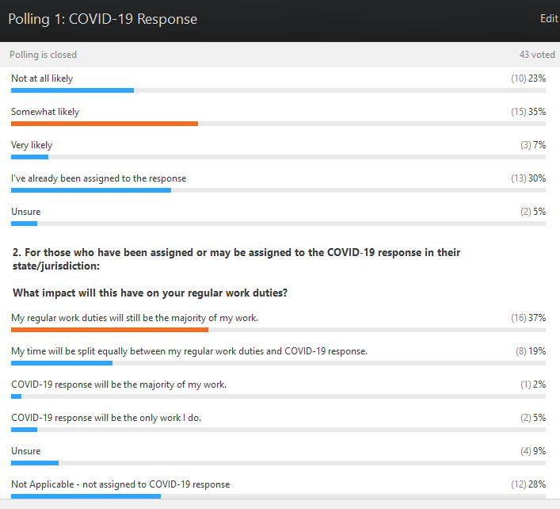  EEC roundtables (epi/eval arrangements and CVD hospitalization codes) have been postponed. | If you did not receive a calendar appointment for this meeting, please add your email address to the Chat and/or email Hannah (hherold@chronicdisease.org).
AMP Update  5 minutes  April | (Update below the agenda table)  Updates included:  - 2019 state DSMES data. This was shared with the meeting invite for today.  - Year 3 evaluation guidance for 1817 Category A:  - Cat A coversheet for Y3 eval  - Y3 Evaluation and Performance Measurement Plan (EPMP) Guidance  - Older 1817 Category A evaluation documents that had been shared via email:  - Sample/Common Evaluation Questions  - EPMP And Performance Measurement Overview Webinar  Health Systems Scorecard was added.  These will be posted to the NACDD internal EEC page – contact Hannah Herold if you don’t have access to the page.
COVID resources  2 minutes  Shelby | COVID map  Conference call BINGO  Fun resources to use during COVID stay-at-home orders and remote work. (Images below agenda table/AMP updates)
COVID-19 and You  15 minutes  Julie | - For CDC-will there be changes in evaluation guidance related to documenting the impact of COVID on our work/results?  Marla (CDC) – We’ve been talking internally, and have plans to start documenting what the challenges are on the projects internally. It’s in all of our best interests to document what the challenges are – staff diverted to COVID response, not able to collect data from health systems, etc. The more you can document those things the more it will help. We have not put out official guidance at this point. I saw the spreadsheet put out by Emily (TX) – any info like that that can be shared with us would help. We can’t put out a form for standard data collection due to OMB, but any personalized info would be good. We’d like to be able to report on staff diversions, challenges in working with health systems, etc. We may be able to come out with more specific guidance in the future.  Hannah (NACDD) – Emily’s spreadsheet is attached to the meeting invite for today.  Deirdre (San Diego) - Thinking long term, should we be tracking the impact of telemedicine on our activities? From clinical work to pharmacy  Ed Clark (FL) – I do!  - What is one way your work has been affected by COVID-19?  April (CO) – We have paused a couple activities. Surveys/interviews of providers implementing bi-directional e-referral (1817 A1 & B6). 1817 A3 media campaign.  Julie (AK) – We have some key informant interviews that are on pause, as well as a survey that was going to be distributed at a conference that is no longer happening.  Edward Clark (FL) – We have a poll to partners to see how they plan to proceed with DPP plans given the current situation. We are setting up some surveys to see what TA they need. Our eval team is being asked to do some sentinel surveillance for COVID.  Debra Hodges (AL???)- While working at home, I have caught up on lots of paperwork that I was behind on, since we had been consumed by reporting and such in Jan. & Feb.  Deidres (San Diego) - Everything is delayed since we have half of our program staff, all evaluation, and greatly reduced activity for programs. Our bi-directional referral partner is 2-1-1 and they are pulled into COVID.  Banita McCarn (Chicago IL???)- All of our work has gone remote. Several of our DPP cohorts have paused or are meeting virtually  Emily Johnson (TX) - We have some partners who moved to virtual lifestyle change programs, and other partners who had to cancel/postpone programs  Tiffany Knauf (ND) - Our 1815 staff has been completely reassigned to the COVID Community Hotline.  Kristine Zimmerman (IL) - In Illinois, all but on 1815 staff at the state has been reassigned  Mengy Li (KS???)- A lot of activities related to hospitals and clinics have been postponed or delayed. Epi/evaluations are assigned to COVID-19 work. Mostly work remotely.  Melissa Chapman Haynes – I’m a contracted evaluator, we’re shifting our duties a little bit to analyze how things are changing due to COVID. We added questions in some surveys about COVID-19. We’re adapting our SOW so we can be responsive.  Alyssa Yang (HI) - 1815 staff in HI are working remotely, but go into the office to work at the call center voluntarily for the covid response. The evaluations with health care systems are on hold for the time being.  Debra Hodges (AL)- The two sites that have developed lifestyle programs and apps are now using the apps to push out COVID-19 messages about sheltering in place, and so on.  - Are you self-isolated?  Many people are sheltering in place and working from home, some are still reporting to the office.  - What is one coping strategy or personal development that is helping you get through ?  Hannah (NACDD) – Virtual trivia nights via Zoom with friends!  April (CO) – Virtual happy hours  Daily yoga and trying out new recipes has been keeping me busy!  Louise Ingraham - Taking walks whenever possible and calling friends.  MaryCatherine (NACDD) – FL is promoting social distancing using an alligator to measure distance https://cdn.cnn.com/cnnnext/dam/assets/200404131604-social-distancing-florida-alligator-trnd-exlarge-169.jpg  Hannah (NACDD) – Texas has a fun way of promoting hand-washing for 20 seconds https://patch.com/img/cdn20/users/22872998/20200305/025853/styles/raw/public/processed_images/Coronavirus%20Social.png  Kelly (NE) – Hashtag “Keep Nebraska Flat” to support flattening the curve in NE  - Any web links or attachments you’d like to share with the group?  Emily (TX): 1815/1817 Excel sheet for tracking how your projects/contracts are affected by COVID-19  Caitlyn - https://slco.org/globalassets/1-site-files/health/programs/covid/socialdistancing_utahns.pdf  Emily Styles (MN) - https://twitter.com/CityMinneapolis/status/1244810814915215362
Adjourn-Next Meeting Wednesday, May 13 at 2pm ET.

Communications
Check the internal EEC webpage for meeting notes and updates: https://www.chronicdisease.org/page/CVH_EEC
Not getting Off the Cuff, NACDD’s weekly Monday newsletter? Email Hannah for assistance hherold@chronicdisease.org

Other News and Updates
**NEW**NACDD, CDC and the Children’s Environmental Health Initiative at Rice University have released a 508-compliant infographic on the GIS Hallmarks. NACDD’s Cardiovascular Health Council, including Shelby (WI) and Rachael (NYS), helped to develop the Hallmarks to promote health department chronic disease GIS capacity by:
- developing a GIS-savvy workforce,
- using GIS to improve partnerships and relationships,
- using GIS to address health equity and social determinants of health, and
- providing financial and administrative resources to support the use of GIS with chronic disease prevention and health promotion programs.

Recording of CDC Clinician Outreach and Communication Activity recording of COVID webinar 4/2/20: https://www.facebook.com/CDCClinicianOutreachAndCommunicationActivity/?deliveryName=DM24697 and https://emergency.cdc.gov/coca/calls/2020/callinfo_040220.asp?deliveryName=DM24697 (Thanks, Shelby!)

AMP Update (Thanks April!)

- 2019 State DSMES Data
Data for 2019 diabetes self-management education and support (DSMES) encounter data provided by the American Diabetes Association (ADA) and the Association of Diabetes Care and Education Specialists (ADCES). The data includes the number of new programs, number of closed programs, total number of programs, and total number of encounters. See EEC Appointment for attachment.
- DP18-1817 Category A Year 3 Evaluation Plan Coversheet (posted 3/12/20)
- DP18-1817 Category A Recipient Year 3 Evaluation and Performance Measurement Plan (EPMP) Guidance (posted 3/12/20)
  - This was mostly guidance text provided in the link vs. a resource. The resource they attached as a file was the EPMP guidance from 2/1/19. Guidance text:
DP18-1817 Category A recipients will submit the following with the Year 3 Annual Performance Report(APR)on April 13, 2020:
Updates to Year 3 performance measure targets based on the Year 3 workplan activities.
Any revisions or updates to the Year 3 Evaluation Plan based on activities planned for Year 3, and feedback received on the Year 2 Evaluation Plan.
Any updates to their data management plan (if needed).
Please note that if there are no changes to your Year 3 Evaluation Plan, recipients should select the option ‘No changes made to the Year 2 Evaluation Plan’ on the DP18-1817 CATEGORY A Year 3 Evaluation Plan Coversheet, rename the Year 2 evaluation plan to reflect Year 3 and upload with the APR.
Please be sure highlight any changes made in yellow in the document and on the Year 3 Evaluation Plan coversheet. A copy of the DP18-1817 Category A EPMP Guidance has been attached for reference and includes sample evaluation questions for each evaluation core area (approach, effectiveness, and impact). For more information on the Evaluation and Performance Measurement Plan, please refer to the DP18-1817 Category A Evaluation and Performance Measurement Plan Guidance. The Coversheet is also provided in AMP.
- DP18-1817 Cat A Sample/Common Evaluation Questions (posted 3/12/20)
  - Attached is a copy of 1817 Cat A Sample Common Evaluation Questions shared in February, 2019 as a follow-up to the DP18-1817 CATEGORY A EPMP AND PERFORMANCE MEASUREMENT OVERVIEW WEBINAR. Please ensure that this information is provided to all staff working on evaluation efforts for 1817. We look forward to working together in our efforts to evaluate the strategies and impact of 1817. Please follow-up with your Category A Evaluator if you have any additional questions.
- DP18-1817 Category A EPMP And Performance Measurement Overview Webinar (posted 3/12/20)
Post of previous webinar for your reference, DP18-1817 CATEGORY A EPMP AND PERFORMANCE MEASUREMENT OVERVIEW WEBINAR we have attached the presentation slides. The written Questions and Answers from the call and the link to the recording are also posted on AMP. Please ensure that this information is provided to all staff working on evaluation efforts for 1817. We look forward to working together in our efforts to evaluate the strategies and impact of 1817. Please follow-up with your Category A Evaluator if you have any additional questions. Additional 1817 Guidance and Resources posted on AMP for 1817 Cat A EPMP:
  - Webinar recording: https://adobeconnect.cdc.gov/pvaizw9jl7wm/
  - PDF copy of slide deck
  - PDF copy of Q/A responses
  - DP18-1817 Category A Recipient Year 3 Evaluation and Performance Measurement Plan (EPMP) Guidance
  - DP18-1817 Cat A Sample/Common Evaluation Questions
  - 1817 Cat A PM Definitions (1817 Category A Performance Measure Definitions)
- Health Systems Scorecard v2.0 (posted 3/19/20)
The Division for Heart Disease and Stroke Prevention is pleased to announce that the updated Health Systems Scorecard is now available on AMP. First disseminated in 2017, the Health Systems Scorecard (HSSC) was developed by the Centers for Disease Control and Prevention (CDC) as a quality improvement assessment tool designed to help state and local health departments and their partner health systems assess evidence-based chronic care management policies and practices. The HSSC addresses preventable risk factors including high blood pressure, high cholesterol, prediabetes or diabetes, obesity, chronic obstructive pulmonary disease, cancer, and tobacco use. Modules in the HSSC include:
    - Multidisciplinary teams for care management approach
    - Clinical guidelines
    - Electronic health record (EHR) systems and patient tracking systems
    - Clinical decision support and protocols
    - Patient education
    - Self-management and care management
    - Tobacco use and dependence cessation
    - Guidelines for screening for breast, cervical, and colorectal cancer
Recipient and SME feedback was used to update the HSSC and the new version (HSSC v2.0) will soon be available online. Before the HSSC v2.0 goes live you may review the updates made to version 2.0 and the supporting guidance. The HSSC v2.0 documents include: the CDC HSSC v2.0 Tool and the CDC HSSC v2.0 Technical Assistance and Resource Guide. The HSSC v2.0 Tool PDF document describes the HSSC that will be available in Formsite® and the new content is highlighted in yellow. This document is not intended for data collection purposes.

