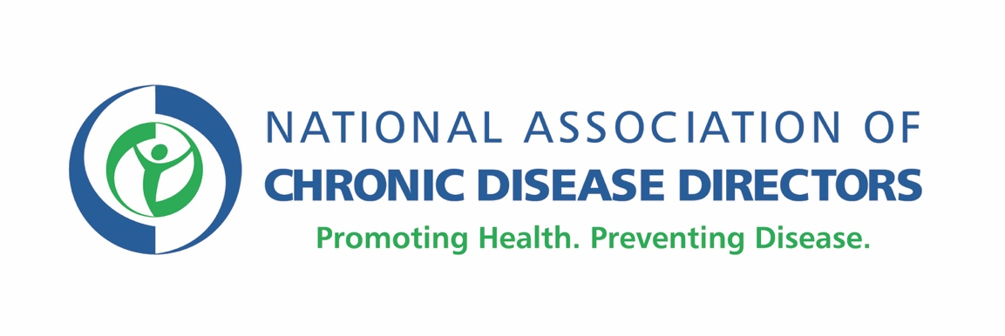
NACDD Inclusive Healthy Communities Comprehensive Sustainability Plan

NACDD created a sustainability planning template to assist current and past Healthy Community grantees with sustainability planning activities to continue project efforts beyond the project funding period. Formerly, this was a required extension of the Community Action Plan (CAP) for community grantees. NACDD encourages your Healthy Community coalition to review the six-part sustainability planning template and begin working through the suggested actions.
Please review the six major sustainability categories highlighted in respective sections below:
- Coalitions and Partnerships;
- Policy, System, and Environmental (PSE) Change Strategies;
- Social Marketing and Communication;
- Integration;
- Mentoring, Sharing and Peer Learning; and
- Funding
Consider activities and partner leads for each to develop your inclusive healthy community sustainability plan. As your work in these areas progresses, please use the spaces available to capture progress, key actions, decisions, and comments as needed.
Part 1: Coalitions and Partnerships

To help your coalition maintain its efforts, the following best practices are recommended:

- Establish/formalize an official coalition if you have not already done so, representative of multiple community sectors (e.g. where people live, learn, work, play, pray, and receive care) and comprised of interdisciplinary members (e.g. public health, disability advocates, planning, transportation, elected officials/decision-makers, etc.);
- Ensure ongoing and permanent integration of PWD and disability advocate members on the Healthy Community coalition;
- Develop and employ a process for leader succession and recruitment of new members;
- Provide recognition and renewal to coalition members to increase energy and reduce burnout;
- Continuously integrate coalition goals and strategies into the missions of its member organizations; and
- Develop diversified funding goals to ensure balance and commitment to inclusive healthy community strategies.
Action Steps | Partner Lead | Timeframe | Progress | Comments
Activity 1:
Activity 2:
Activity 3:
Activity 4:
Activity 5:
(add additional rows as needed)
Part 2: PSE Change Strategies

To sustain important coalition PSE work once it is achieved, the following activities are recommended:

- Continued implementation of PSEs on the CAP and/or development of new PSEs through community-driven and data-driven processes; and
- Monitoring current PSE efforts and capitalizing on flexibility, momentum, feasibility, and impact.
Action Steps | Partner Lead | Timeframe | Progress | Comments
Activity 1:
Activity 2:
Activity 3:
Activity 4:
Activity 5:
(add additional rows as needed)
Part 3: Social Marketing and Communication

Social marketing campaigns are critical, effective, and cost-efficient tools for jump-starting a coalition’s efforts to gain support from the various sectors of the public to support PSE change strategies, and/or to help decision-makers understand and support inclusive healthy community efforts. Communication strategies to consider using include:

- Use of Traditional Media (e.g. print, television, radio, etc.), Non-Traditional Media (e.g. podcasts, blogging, etc.), and Social Media (e.g. Facebook, Twitter, Instagram, YouTube, LinkedIn, etc.);
- Educating Decision-Makers (e.g. elected officials, appointed officials, community influencers, etc.); and
- Targeting Messages to Key Decision Makers by framing and reframing.
Action Steps | Partner Lead | Timeframe | Progress | Comments
Activity 1:
Activity 2:
Activity 3:
Activity 4:
Activity 5:
(add additional rows as needed)
Part 4: Integration

Once the coalition has implemented PSEs and worked on communicating its message, it is important to identify a community home for the coalition and work efforts. When identifying a “community home” for the coalition, please consider the following:

- Capacity to solicit and accept a variety of funding sources;
- Appeal to the interests of a variety of community-based organizations;
- Ability to shift priorities to accommodate changes in goals and community;
- Internal administrative, governance, planning, and evaluation of infrastructure to manage competing interests; and
- Organization absorption of PSE CAP strategies.
Action Steps | Partner Lead | Timeframe | Progress | Comments
Activity 1:
Activity 2:
Activity 3:
Activity 4:
Activity 5:
(add additional rows as needed)
Part 5: Mentoring, Sharing, and Peer Learning

A crucial step to sustaining PSE coalition work locally is to spread the good work being done by your own group with others. This provides an opportunity to:

- Reflect on and celebrate your successes;
- Integrate intra-coalition education during coalition meetings as a way of mentoring Healthy Community aspects to community partners;
- Share successes and lessons learned with local, regional, state or national partners; and
- Learn from others on what best-practices are working within their coalition and replicate where possible.
Action Steps | Partner Lead | Timeframe | Progress | Comments
Activity 1:
Activity 2:
Activity 3:
Activity 4:
Activity 5:
(add additional rows as needed)
Part 6: Funding

Perhaps the most important step to sustaining PSE coalition work locally is to secure additional funding and leverage additional resources that will keep your inclusive healthy community project active after the funding/project period ends. Strategies to consider are:

- Write and obtain additional grants;
- Advocate for coach/coordinator positions to be absorbed (i.e. “provided”) by agency, board, local government, etc.;
- Identify “What’s the problem and who’s the champion?” among community partners; and
- Organization absorption of PSE CAP strategies and commitment for ongoing implementation.
Action Steps | Partner Lead | Timeframe | Progress | Comments
Activity 1:
Activity 2:
Activity 3:
Activity 4:
Activity 5:
(add additional rows as needed)

