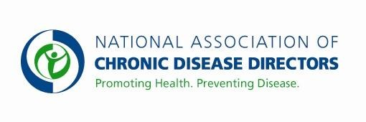
COLORECTAL CANCER CONTROL PROGRAM
FY 2020 APPROPRIATIONS FACT SHEET
CENTERS FOR DISEASE CONTROL AND PREVENTION

FY 2018 | FY 2019 | FY 2020 President’s Budget | FY 2020 Request
$43,294,000 | $43,294,000 | * | $70,000,000

Colorectal cancer (CRC) is the second leading cause of cancer deaths in the United States (U.S.) for men and women. Every year, about 140,000 Americans are diagnosed with CRC, and more than 50,000 people die from it. Colorectal cancer screening is a recommended clinical preventive service that not only detects cancer early when treatment is more effective but can prevent cancer by removing pre-cancerous polyps. The percentage of U.S. adults aged 50 to 75 years with up-to-date CRC screening was 67.3% in 2016, an increase of 1.1% from 2014. National CRC screening rates have remained relatively level since 2010 after steadily increasing over the previous decade. Through the Colorectal Cancer Control Program (CRCCP), CDC is working to address the issue by providing funding to 30 grantees (22 States, the District of Columbia, 6 Universities, and one Tribal Organization) to increase CRC screening rates among men and women aged 50 to 75 years. Funding the program at $70 million would allow CDC to expand the program nationwide to all 50 states – and increase the use of life-saving cancer screening among unscreened adults.

Basic Facts about Colorectal Cancer:
- Among cancers affecting both men and women, colorectal cancer is the second leading cause of cancer-related deaths in the U.S. In 2015, 52,396 people in the United States died of colorectal cancer (27,508 men and 24,888 women).
- One quarter of U.S. residents (25.7%), or 22 million aged 50-75 years, have never been screened for CRC. Among the never-screened, 85% are insured and 82.3% are aged 50 to 64 years.
- Estimated direct medical costs for colorectal cancer care in 2010 were $14 billion with projected costs of up to $20 billion by 2020.

CDC’s Colorectal Cancer Screening Program

In FY 2015, CDC awarded new 5-year funding to 30 grantees to focus on implementing health systems changes designed to increase CRC screening rates. Funding is used by grantees to partner with health systems and clinics that serve low-income, high need populations to implement evidence-based interventions (provider assessment/feedback, provider reminders, client reminders, reducing structural barriers) and other strategies (patient navigation, small media) proven to increase screening. Currently grantees are working with over 540 clinics in 180 health systems and over 4,400 providers that serve almost 1 million patients age 50 - 75. The majority of clinics are Federally Qualified Health Centers who have high percentages of uninsured or underserved patients. Grantees report baseline and annual screening rates for all clinics allowing CDC to assess the impact of the CRCCP. After year 2 of the program, the average clinic screening rate increased 8.3% from 43.2% to 51.5% which equates to almost 59,000 additional people screened.

For more information, visit: https://www.cdc.gov/cancer/colorectal/
Contact: Amy Souders, Cornerstone Government Affairs. (202) 488-9500 or asouders@cgagroup.com

