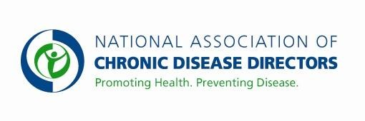
TOBACCO CONTROL
FY 2019 APPROPRIATIONS FACT SHEET CENTERS FOR DISEASE CONTROL AND PREVENTION

FY 2017 | FY 2018 | FY 2019 President’s Budget | FY 2019 Request
$205,000,000 | $210,000,000 | $* | $220,000,000
*This budget line is proposed for consolidation in the America’s Health Block Grant

CDC is the lead federal agency for comprehensive tobacco control and prevention efforts. CDC provides federal leadership by developing, conducting and supporting strategic efforts to protect the public’s health from the harmful effects of tobacco use. Tobacco prevention and control is one of the “best buys” in public health: states with strong programs have demonstrated a $55:$1 return on their investment. Funding would be used to:

- Support the National Tobacco Control Program, which works to prevent tobacco initiation among youth; promote quitting among youth and adults; eliminate exposure to secondhand smoke; and identify and eliminate tobacco-related disparities.
- Support cessation-focused health care systems changes and enhanced service delivery.
- Enhance national tobacco control surveillance infrastructure, including rapid response capability to inform stakeholders of emerging public health concerns related to tobacco.

Basic Facts about Tobacco Use
- Tobacco use is the single most preventable cause of death and disease in the United States. Smoking harms nearly every organ of the body, causing many diseases and affecting the health of smokers in general.
- Each day in the U.S. more than 3,200 youth aged 18 or younger smoke their first cigarette, and an additional 2,100 youth and young adults become smokers. Approximately 5.6 million of today’s youth are projected to die prematurely from a smoking-related illness if current smoking rates continue.
- Each year, an estimated 480,000 people die prematurely from cigarette smoking, including an estimated 41,000 deaths resulting from secondhand smoke exposure. This is about one in five deaths annually, or 1,300 deaths every day. For every person who dies because of smoking, at least 30 people live with a serious smoking-related illness.
- Tobacco use costs nearly $170 billion in direct medical care for adults each year and an additional $156 billion in lost productivity.
- Among current U.S. adult cigarette smokers, 68% report that they want to quit completely.

CDC’ s Tobacco Control Program
CDC funds the development, implementation and evaluation of tobacco control programs in all 50 states, the District of Columbia, twelve tribal support organizations, eight U.S. territories, and eight national networks representing priority populations. CDC conducts tobacco surveillance and translates science into best practices that help the public health community plan, implement, evaluate and sustain tobacco prevention and control efforts. CDC identifies rapidly developing trends in tobacco use, and educates the public on the health hazards of tobacco use. CDC expands knowledge of the health risks of nicotine, additives and other potentially toxic compounds in tobacco products through laboratory research.

*For more information visit www.cdc.gov/tobacco
Contact: Amy Souders, Cornerstone Government Affairs. (202) 488-9500 or asouders@cgagroup.com

