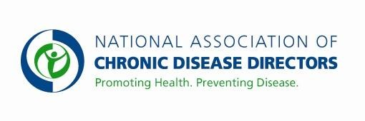
DIVISION FOR HEART DISEASE AND STROKE PREVENTION FY 2019 APPROPRIATIONS FACT SHEET
CENTERS FOR DISEASE CONTROL AND PREVENTION

FY 2017 | FY 2018 | FY 2019 President’s Budget | FY 2019 Request
$130,037,000 | $140,062,000 | $* | $160,037,000
*This budget line is proposed for consolidation in the America’s Health Block Grant
CDC’s Heart Disease and Stroke Prevention Program
CDC works with state health agencies and other partners to prevent, detect, and treat risk factors for heart disease and stroke. CDC supports state-based heart disease and stroke prevention activities, the Paul Coverdell Acute Stroke Registry Program, Sodium Reduction in Communities Program, and the WISEWOMAN program.

Funding this program at $160,037,000 will allow CDC to continue to provide critical resources for states to focus on this common and often preventable cause of death and disability.

Basic Facts about Heart Disease and Stroke
• Heart disease and stroke are the first and fifth leading causes of death in the United States.
• More than 635,000 people die in the United States each year from cardiovascular diseases—that’s 1 in every 4 deaths. Approximately every 40 seconds, an American will have a coronary event, and approximately every minute, someone will die of one.
• Each year, an estimated 795,000 people experience a stroke. On average, one American dies from stroke every 4 minutes.

Cost of Heart Disease and Stroke to the American Health Care System
• About 1 in every 7 health care dollars, or 15%, is spent on cardiovascular disease.
• The total direct and indirect cost of cardiovascular disease and stroke in the United States for 2013-2014 was estimated to be about $330 billion. The total annual costs associated with high blood pressure were estimated to be over $53 billion in 2013-2014.

Heart Disease and Stroke are Preventable and Controllable

• About half of U.S. adults (47%) have at least one of the following major risk factors for cardiovascular disease: uncontrolled high blood pressure, uncontrolled high LDL (bad) cholesterol, or are current smokers.
- Nearly 1 in 3 U.S. adults, around 75 million, have high blood pressure. The estimate will increase to 4 in 9 or over 100 million, respectively, when the hypertension definition recommended from the recently released 2017 Hypertension Guideline is applied.
• Reducing average population sodium intake by 400 mg per day could prevent up to 28,000 deaths annually from any cause and save up to $7 billion health care dollars each year.
• A 10% decrease in total cholesterol levels in the U.S. population overall may result in an estimated
30% reduction in the incidence of coronary heart disease.
- Cigarette smokers are 2-4 times more likely to develop heart disease and 2-4 times more likely to have a stroke as nonsmokers.

* For more information visit www.cdc.gov/dhdsp
Contact: Amy Souders, Cornerstone Government Affairs. (202) 488-9500 or asouders@cgagroup.com

