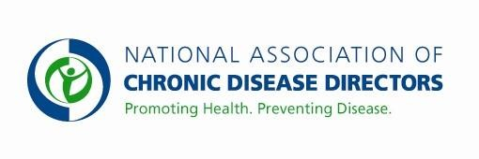
NATIONAL COMPREHENSIVE CANCER CONTROL PROGRAM FY 2019 APPROPRIATIONS FACT SHEET
CENTERS FOR DISEASE CONTROL AND PREVENTION

FY 2017 Final | FY 2018 | FY 2019 President’s Budget | FY 2019 Request
$19,675,000 | $19,675,000 | TBD | $50,000,000

The CDC National Comprehensive Cancer Control Program (NCCCP) establishes comprehensive cancer control (CCC) coalitions, defines cancer priorities in each state and provides the evidence base for effective cancer prevention and control. Minimal funding is provided to CDC to support all 50 states, the District of Columbia, 6 U.S. Associated Pacific Island Jurisdictions and Puerto Rico, and 8 tribes or tribal groups. Additional resources would enhance the national, state and local ability to prevent and control cancer. Specifically, increased funding would support enhanced primary prevention efforts, increased access to early detection and quality treatment, and efforts to improve the quality of life of cancer survivors.

The NCCCP uses evidence-based approaches aimed at primary prevention (e.g., increasing physical activity), detecting cancers earlier when they are more treatable (e.g., colorectal cancer screening), increasing access to treatment, and improving the quality of life of cancer survivors. In addition to these priorities, the NCCCP is focusing efforts on achieving an 80% screening rate for colorectal cancer by 2018, increasing HPV vaccination completion rates, increasing healthy behaviors among cancer survivors, and sustaining comprehensive cancer control coalitions. Additional funding would significantly increase NCCCP grantee’s ability to move the needle in these priority areas.
Basic Facts About Cancer
- One in three Americans will be diagnosed with cancer in their lifetime.
- Cancer is the second leading cause of death in the United States, resulting in over 580,000 deaths annually.
- Cancer kills more American Indian/Alaska Natives, Asian/Pacific Islander and Hispanic
Americans than any other disease, regardless of age.
- The number of Americans living with a previous diagnosis of cancer, currently estimated at almost 14 million, is on the rise.
- Cancer cost the United States an estimated $157 billion in medical expenses in 2010, and this number is expected to increase substantially over the next 10 years.

CDC’ s National Comprehensive Cancer Control Program
Working in communities across the nation to promote healthy lifestyles, support recommended cancer screenings, educate people about cancer symptoms, increase access to quality cancer care, and enhance cancer survivors’ quality of life. CDC is working with NCCCP grantees to focus on six strategic priorities: emphasizing primary prevention, coordinating early detection and treatment interventions, addressing the public health needs of cancer survivors, implementing policies to sustain cancer control, eliminating health disparities to achieve health equity and ensuring impact and use of evidence and evaluation. NCCCP programs work to reduce the number of illnesses and deaths caused by cancer in every state in the U.S.

Visit the CDC website for NCCCP Success Stories.

Contact: Amy Souders, Cornerstone Government Affairs. (202) 488-9500 or asouders@cgagroup.com

