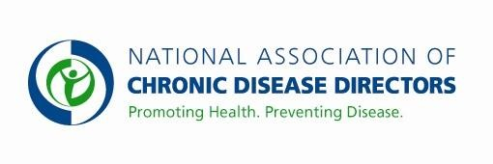
ALZHEIMERS DISEASE PROGRAM
FY 2019 APPROPRIATIONS FACT SHEET CENTERS FOR DISEASE CONTROL AND PREVENTION

FY 2017 | FY 2018 | FY 2019 President’s Budget | FY 2019 Request
$3,500,000 | $4,500,000 | $* | $10,000,000
*This budget line is proposed for consolidation in the America’s Health Block Grant.

Currently all states are grossly underfunded to address the public health needs of adults in the US given the rapid growth of our aging population. The scientific community, Congress, and the Administration have identified Alzheimer’s disease (the most common form of dementia) as a priority area, resulting in the first National Plan to Address Alzheimer’s Disease. The suggested increase will enable some states to expand their efforts and allow CDC to fund activities that support state-based programs to address this looming public health crisis, as outlined in The Healthy Brain Initiative: The Public Health Road Map for State and National Partnerships.

Basic Facts
- An estimated 5.5 million Americans had Alzheimer’s disease in 2017, including an estimated 5.3 million people aged 65 and older. The number of new cases of Alzheimer’s and other dementias is projected to triple by 2050.
- According to CDC, Alzheimer’s disease is the sixth-leading cause of death in the United States. It is the fifth leading cause of death for those age 65 and older. Recent studies indicate that the actual ranking is the third leading cause of death.
- Total payments for health care, long-term care and hospice were estimated to be $259 billion in 2017 for people with Alzheimer’s disease and other dementias.
- Living with Alzheimer’s disease compounds medical costs and the burden of disease, since 83% of adults 85 and older and 75% of adults 65 and older have 2 or more concurrent chronic conditions.

Use of Evidence-based Strategies
- Prevention and health promotion strategies exist to reduce many of the risk factors for unnecessary disability and death. Older adults often benefit the most from public health interventions.
- Medical care alone will not meet the health needs of older adults – advance planning, clinical-community linkages, and social supports and interventions outside of the aging services network are crucial to respond to
older adults’ needs.
- State public health agencies have an integral role to play in supporting the evidence, coordinating programs across state government, educating providers and the public, and employing a population-based approach that will complement the individual and small group approaches of medical care and social care.
- Every state should have a comprehensive plan to address Alzheimer’s disease.

CDC's Healthy Aging Program
CDC has worked to build the science base that will inform public health action for healthy aging. With an appropriation of $10 million, CDC can partner with groups like NACDD to ensure education of public health professionals and support pilot states in the implementation of the National Plan to Address Alzheimer’s Disease. These states will develop comprehensive plans to support the implementation, availability and dissemination of proven strategies. This will include approaches to broaden the use of clinical preventive services and community-based long term care strategies and policies to ensure functional independence and enhance quality of life, including a focus on caregiving.

*For more information visit www.cdc.gov/aging
Contact: Amy Souders, Cornerstone Government Affairs. (202) 488-9500 or asouders@cgagroup.com

