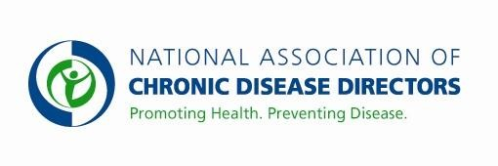
HEALTHY SCHOOLS, HEALTHY YOUTH FY 2018 APPROPRIATIONS FACT SHEET
CENTERS FOR DISEASE CONTROL AND PREVENTION

FY 2016 | FY 2017 President’s Budget | FY 2017 House | FY 2017 Senate | FY 2018 Request
$15,383,000 | $15,400,000 | $15,400,000 | $15,400,000 | $23,400,000

Reversing the obesity epidemic and promoting children’s health requires a long-term, well-coordinated approach to reach young people where they live, learn and play—and schools have an especially important role. The proposed increase will enable more states to establish or increase strategic school health efforts to help fight the obesity epidemic among children. Additional funds will also help states improve the management of chronic conditions such as asthma and diabetes in the school setting. Each school day is an opportunity for the nation’s 56 million students to be in a healthy learning environment and practice lifelong healthy habits.

Basic Facts About Children’s Health
- Childhood obesity has more than doubled in children and quadrupled in adolescents in the past 30 years.
- In 2013, more than one third of children and adolescents were overweight or obese.
- An estimated 70% of obese children aged 5 to 17 years already have at least one risk factor for heart disease.
- Less than one-third of high school students participate in daily physical education classes and 73% were not active daily for 60 minutes or more.
- Most adolescents (78%) do not eat the recommended daily number of servings of fruits and vegetables, and they drink more full-calorie soda than milk per day.

CDC’s School Health Program
Chronic diseases are responsible for 7 of 10 deaths each year, and treating people with chronic diseases accounts for 86% of our nation’s health care costs. Establishing healthy behaviors during childhood is easier and more effective than trying to change unhealthy behaviors during adulthood. Schools can help promote the health of young people and help them establish lifelong healthy patterns—including nutrition and physical activity behaviors that can prevent obesity and related diseases. Schools play a critical role in modeling and reinforcing healthy dietary and physical activity behaviors. In addition, 1 in 4 students have a chronic condition that impacts their well-being. It is essential that schools are prepared to help students best manage their chronic conditions in the school setting and connect to student medical homes.

The academic success of America’s youth is strongly linked with their health. Scientific reviews have documented that school health programs can have positive effects on educational outcomes, as well as health-risk behaviors and health outcomes. Health-related factors such as hunger, chronic illness and physical inactivity can lead to poor school performance and academic outcomes. In addition, children with chronic health conditions may face lower academic achievement, increased disability, fewer job opportunities and limited community interactions as they enter adulthood.

Current funding to states allows for only limited efforts to support student health. To enable all states to fully implement recommended strategies to reduce obesity, improve related health outcomes, promote student health with better nutrition environments, physical activity opportunities and physical education and improve chronic conditions management for youth, an additional $8 million is needed in FY17.

For more information, visitwww.cdc.gov/healthyschools
Contact: Amy Souders, Cornerstone Government Affairs. (202) 488-9500 or asouders@cgagroup.com

