Additional Online Communications Tools and Resources
The Communications Department has compiled a list of royalty-free or open-source graphics, images, and audio databases and resources to support your communications projects.
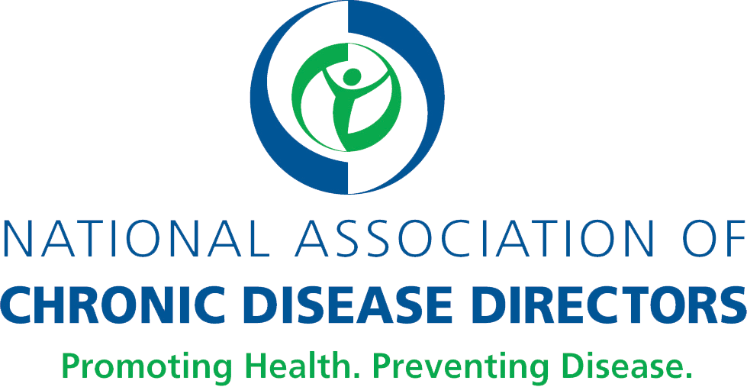

Stock images
- Stock.XCHNG (freeimages.com): Has more than 50 pages of pharmacy-oriented healthcare photos.

- Dreamstime (dreamstime.com): Has more than 15,000 health care photos that emphasize natural health and healthy living.

- Unsplash (unsplash.com): High-resolution photo collections that highlight healthy foods and health, fitness, and wellness.

- StockSnap.io (stocksnap.io): High-resolution photos that focus on landscape, outdoors and exercise.

- CDC’s Public Health Image Library (phil.cdc.gov/phil/home.asp): Includes images of influenza, natural disasters, environmental health, bioterrorism, everyday activities, EM imagery, health behaviors, public health in action, laboratory science, and developmental milestones.

- National Eye Institute (NEI) Media Library (medialibrary.nei.nih.gov): A multimedia collection with a variety of engaging, scientifically accurate images and videos about eye health.

- Death to the Stock Photo (deathtothestockphoto.com): An artist-driven co-op for high-quality images designed for the web

- Little Visuals (littlevisuals.co): Features artistic images of landscapes, objects etc.

- Pic Jumbo (picjumbo.com): Various images.

- Trans/non-binary health from Vice Media (broadlygenderphotos.vice.com): A free stock library of images of trans and non-binary models, including a health section.

- Freeimages (freeimages.com): collection of high-quality images; mostly landscape, has search function

- Wylio (wylio.com): Search engine for creative commons licensed photographs

Vector art/graphics
- Vecteezy (vecteezy.com): Vector images allow for more flexibility because they can be resized without losing sharp resolution.

- The Noun Project (thenounproject.com): A collection of 1000+ icons, mostly black and white

Audio libraries
- YouTube Audio Library (youtube.com/audiolibrary/music): YouTube Audio Library has different types of audio files, ranging from background music to sound effects.

- Free Stock Music (freestockmusic.com): Audio files include cinematic music, easy listening, and other categories such as classical and corporate.

Graphic design tools
- Canva (canva.com): Canva allows users to use drag-and-drop features and professional layouts in design graphics.

- The Creative Bloq (Creativebloq.com): A collection of inspiration and how-to guides

Color resources
- Adobe Color wheel (color.adobe.com/create): Shows color palettes based on a color you choose

- Color Image Search (labs.tinyeye.com): Search for a color and creative commons images that use the same color.

Fonts
- Google Fonts: fonts.google.com
- Which google fonts work together: The art of mixing typefaces
- Adobe: (fonts.adobe.com)
- Font Awesome (fontawesome.com): has lots of fonts and icons for free or pay

Accessibility

- W3C Accessibility guide (w3.org/standards/webdesign/accessibility): a collection of guidelines for creating disability-conscious Web designs

- WebAim Contrast Checker (webaim.org/resources/contrastchecker): evaluates contrast and color for accessibility

- Paletton (paletton.com): Allows you to develop palettes and see how they would look with various vision impairments

