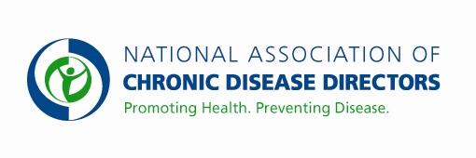
PREVENTIVE HEALTH AND HEALTH SERVICES BLOCK GRANT
FY 2019 APPROPRIATIONS FACT SHEET
CENTERS FOR DISEASE CONTROL AND PREVENTION

FY 2017 | FY 2018 | FY 2019 President’s Budget | FY 2019 Request
$ 160,000,000 | $160,000,000 | $* | $170,000,000
*This budget line is proposed for a consolidation in the America’s Health Block Grant.

Basic Facts about the Preventive Health & Health Services Block Grant
The Preventive Health and Health Services Block Grant allows 50 states, 2 American Indian tribes, 8 U.S. territories, and the District of Columbia the autonomy and flexibility to tailor prevention and health promotion programs to their particular public health needs. Funds are used to provide support to areas where no federal or state support exists, or where federal categorical funds are grossly insufficient. For example: Pennsylvania, along with 9 other states, has no categorical funds for heart disease and stroke prevention. Block Grant funds provide the only source of funding for these activities in those states. In several states, Block Grant funds support screening of additional women in the Breast and Cervical Cancer Screening Program. The flexibility of this grant allows each state to address its own unique challenges in innovative ways.

Currently, 56 percent of Block Grant dollars are used to supplement existing funds. 33 percent support programs where there are no existing federal or state funds, 9 percent support program start-ups, and 2 percent support rapid response. Examples of current funding areas include chronic disease prevention and control, emergency medical services, environmental health, infectious disease prevention and control, community-based education, injury prevention and control, disease and risk factor surveillance and lead poisoning prevention.

Preventive Health & Health Services Block Grant Programs
The Preventive Health and Health Services Block Grant allows grantees to address emerging health issues and gaps by focusing on their specific needs at the state level. States use Block Grant funding to reduce premature deaths and disabilities by focusing on the leading preventable risk factors in their specific population. The flexibility afforded grantees allows them to address the social determinants of health with the aim of achieving health equity in the long-term.

Many states have used this block grant funding to address unanticipated public health emergencies, such as outbreaks of deadly salmonella infections or West Nile Virus, and/or to implement heart attack, stroke and other cardiovascular disease prevention programs, cancer screenings, dental health programs, child safety seat or smoke detector programs and public health education programs designed to target at-risk populations.

Additional information available at www.chronicdisease.org/policy
Contact: Amy Souders, Cornerstone Government Affairs. (202) 488-9500 or asouders@cgagroup.com

