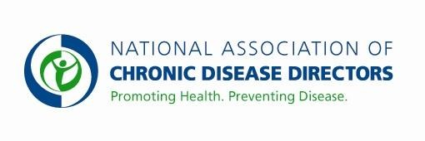
COLORECTAL CANCER CONTROL PROGRAM
FY 2019 APPROPRIATIONS FACT SHEET
CENTERS FOR DISEASE CONTROL AND PREVENTION

FY 2017 | FY 2018 | FY 2019 President’s Budget | FY 2019 Request
$43,294,000 | $43,294,000 | TBD | $70,000,000

Colorectal cancer (CRC) is the second leading cause of cancer deaths in the United States (U.S.) for men and women. Every year, about 140,000 Americans are diagnosed with CRC, and more than 50,000 people die from it. Colorectal cancer screening is a recommended clinical preventive service that not only detects cancer early when treatment is more effective but can prevent cancer by removing pre-cancerous polyps. The percentage of U.S. adults aged 50 to 75 years with up-to-date CRC screening was 67.3% in 2016, an increase of 1.1% from 2014. National CRC screening rates have remained relatively level since 2010 after steadily increasing over the previous decade. Through the Colorectal Cancer Control Program, CDC is working to address the issue by providing funding to 30 grantees (22 States, the District of Columbia, 6 Universities, and one Tribal Organization) to increase CRC screening rates among men and women aged 50 to 75 years. With additional funding of $28 million, CDC could expand the program nationwide to all 50 states – and increase the use of life-saving cancer screening among unscreened adults.

Basic Facts about Colorectal Cancer:
- Among cancers affecting both men and women, colorectal cancer is the second leading cause of cancer-related deaths in the U.S. In 2014, 51,651 people in the United States died of colorectal cancer (27,134 men and 24,517 women).
- One quarter of U.S. residents (25.6%), or 22 million aged 50-75 years, have never been screened for CRC. Among the never-screened, 85% are insured and 82.3% are aged 50 to 64 years.
  - If everyone aged 50 or older had regular screening tests and all precancerous polyps were removed, as many as 60% of deaths from CRC could be prevented.
- Estimated direct medical costs for colorectal cancer care in 2010 were $14 billion with projected costs of up to $20 billion by 2020.

CDC’s Colorectal Cancer Screening Program

In FY 2015, CDC awarded new 5-year funding to 30 grantees. The new CRCCP funding focuses on implementing health systems changes to strengthen organized approaches to increasing CRC screening rates. The focus on health-systems change complements increases in insurance coverage provided through the ACA. Grantees partner with health systems and clinics that serve low-income, high need populations to implement evidence-based interventions (provider assessment/feedback, provider reminders, client reminders, reducing structural barriers) and other supporting strategies (patient navigation, small media). Grantees report baseline and annual screening rates for all clinics allowing CDC to assess the impact of the CRCCP. Six of the 30 grantees also receive funding to support direct CRC screening of low income, uninsured and underinsured individuals aged 50-75 years of age.

Contact: Amy Souders, Cornerstone Government Affairs. (202) 488-9500 or asouders@cgagroup.com

