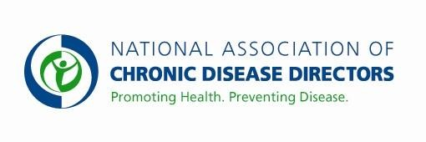
NATIONAL PROGRAM OF CANCER REGISTRIES
FY 2019 APPROPRIATIONS FACT SHEET
CENTERS FOR DISEASE CONTROL AND PREVENTION

FY 2017 | FY 2018 | FY 2019 President’s Budget | FY 2019 Request
$49,440,000 | $49,440,000 | TBD | $65,000,000

Cancer kills more Americans under age 85 than heart disease. One of every four deaths in the U.S. is from cancer, costing over $220 billion in annual medical expenses. Cancer surveillance, an indispensable tool, enables public health professionals to track and respond to the cancer burden at the local, state and national levels.

The Need for Greater Resources
Additional funding is needed to support states and territories to enhance the overall quality and completeness of registry data, to improve their ability to use registry data to report on cancer trends and monitor program impact, and to respond to public inquiries and concerns regarding cancer occurrence. With these additional resources, CDC would increase support to state registries to: improve capacity for using cancer data to develop and evaluate interventions; conduct special data linkages; improve speed of reporting; increase the scope of data collected including more detailed treatment data; and increase the use of electronic health records (EHRs). Enhanced use of EHRs will improve the timeliness, completeness and quality of cancer data reported from non-hospital facilities and increase public health programs' ability to plan and target health care interventions designed to reduce cancer incidence or improve early detection.

CDC National Program of Cancer Registries
The National Program of Cancer Registries (NPCR) is the backbone of CDC’s cancer prevention and control programs. State-based cancer registries are data systems designed to gather, manage and analyze data about incidence, stage at diagnosis and treatment. This information is used to: guide planning and evaluation of cancer control programs; help allocate health resources; contribute to clinical, epidemiologic and health services research; and respond to citizen concerns over the presence of cancer in their communities.

CDC’s NPCR supports over 50 cancer registries - 46 states, the District of Columbia, Puerto Rico, US Pacific Island jurisdictions, and the US Virgin Islands. When combined with the National Cancer Institute’s Surveillance, Epidemiology, and End Results Program, CDC creates the United States Cancer Statistics, an annual census of cancer cases in the US. Complete and accurate data strengthens local cancer programs, provides understanding of national trends, cancer burden in special populations, and regional variations in cancer, and provides new insights into rare childhood cancers, brain tumors and others. Through the NPCR, CDC collected detailed information on over 1,600,000 new cancer cases in 2014. CDC is a leader in the promotion and implementation of innovative approaches to automated electronic reporting in public health surveillance. NPCR has coordinated implementation of standardized electronic pathology reporting from 25 national/regional laboratories to more than 45 central cancer registries. Additionally, NPCR was successful in obtaining cancer reporting as a menu option in Stages 2 and 3 of Meaningful Use and over 40 states are ready to receive the cancer reports with at least 32 currently testing files received from physician offices.

*For more information visit, http://www.cdc.gov/cancer/npcr
Contact: Amy Souders, Cornerstone Government Affairs. (202) 488-9500 or asouders@cgagroup.com

