June 13, 2014

The Honorable Sylvia Mathews Burwell
Secretary of Health and Human Services
U.S. Department of Health and Human Services
200 Independence Ave., SW
Washington, DC 20201
Dear Secretary Burwell,
On behalf of the National Association of Chronic Disease Directors, I am writing to offer our sincere congratulations on your recent confirmation as the United States Secretary of Health and Human Services.
The National Association of Chronic Disease Directors (NACDD) is a non-profit, public health organization committed to serve the chronic disease program directors of each state and U.S. jurisdiction. Founded in 1988, NACDD connects more than 4,000 chronic disease practitioners to advocate for preventive policies and programs, encourage knowledge sharing and develop partnerships for health promotion. Since its founding, NACDD has been a national leader in mobilizing efforts to reduce chronic diseases and their associated risk factors through state and community-based prevention strategies.
Nearly half (45 percent) of all Americans suffer from at least one chronic disease, with more than one in four with multiple chronic conditions. More than two-thirds of all deaths are caused by one or more of five chronic diseases: heart disease, cancer, stroke, chronic obstructive pulmonary disease, and diabetes. The nation’s aging population, coupled with concerning trends in existing risk factors (tobacco use, poor nutrition, lack of physical activity), lead to the only conclusion that these problems are going to grow if they are not effectively addressed now.
We know that chronic disease not only affects health and quality of life, but is also a major driver of health care costs and has a related impact on business, as reflected in absenteeism and presenteeism. According to the Centers for Disease Control and Prevention (CDC), chronic disease accounts for approximately 75 percent of the nation's aggregate health care spending - or an estimated $5,300 per person in the U.S. annually. In terms of public insurance, treatment of chronic disease constitutes an even larger portion of spending - 96 cents per dollar for Medicare and 83 cents per dollar for Medicaid. Behavioral choices that result in an increased incidence of chronic disease are also extremely costly in terms of the affordability of health care coverage.
We are encouraged that the United States Congress through the Fiscal Year 2014 appropriations process has expressed a commitment to prevention through the allocation of the Prevention and Public Health Fund. The allocation of the fund to prevention programs at CDC for Diabetes, Heart Disease and Stroke and the Prevent Block Grant will give states and their local partners the opportunity to expand existing state-based activities and local-level partnerships to address these chronic conditions. We continue to work with the Administration to demonstrate the needs of the public health community as the funding from the appropriations process is put into the field.
We look forward to working with you as we continue the fight to prevent chronic disease across the country.
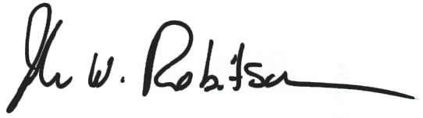
Sincerely,

John W. Robitscher
Chief Executive Officer

Cc: Jill Myers-Geadelmann, President
David Hoffman, Policy Chair

