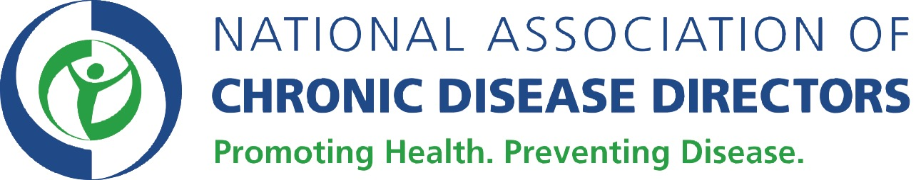

June 15, 2015

The Honorable Pete Sessions The Honorable Louise Slaughter
Chair Ranking Minority Member
House Rules Committee House Rules Committee
Washington, DC 20515 Washington, DC 20515

Dear Representatives Sessions and Slaughter:

I understand that the House Rules Committee later today will consider H.R. 1190, which would repeal the Independent Payment Advisory Board. We have learned that Representative Pitts is offering an amendment in the Rules Committee to offset the cost of the bill by rescinding $8.85 billion from the Prevention and Public Health Fund (PPHF). The National Association of Chronic Disease Directors (NACDD) strongly opposes efforts to rescind funds from the Prevention Fund. NACDD is the single voice of state health department chronic disease prevention and control professionals. Representing nearly 6,000 specialized professionals in every state and U.S. Territory, NACDD works in communities to promote health and prevent disease.

Using the Prevention Fund to pay for other purposes will only harm the long-term health and economy of our nation. Cutting resources from the Fund would slash investments and public health efforts in every state and set back the public health. It would leave the Centers for Disease Control and Prevention (CDC) with a gaping budget hole (for example, the Fund currently supports 46 percent of the funding for the National Center for Chronic Disease Prevention and Health Promotion) and end programs such as the Prevention Block Grant program (which was doubled in FY14 when it was moved into the Fund), Diabetes Prevention, Heart Disease and Stroke prevention, and Obesity prevention. Repealing the Fund would also slash funding for an important immunization program that has been vital to preventing and responding to measles outbreaks, as well as reducing support for the epidemiology and laboratory capacity of all states, both of which are key to preventing and containing infectious disease outbreaks.

We urge you to oppose this misguided effort to rescind funds from the Prevention and Public Health Fund.

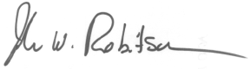
Sincerely,

John Robitscher
CEO
CC: David Hoffman, Policy Chair
Amy Souders, Cornerstone Government Affairs

